PODZEMNE BUŠAĆE MAŠINE

UNDERGROUND DRILLING MACHINES

HКР100МA, HКР100МПA, HКР100МBA, HКР100МBПA

KATALOG DIJELOVA I SKLOPOVA

CATALOG OF PARTS AND ASSEMBLY UNITS

Kako koristiti katalog
Katalog delova i montažnih jedinica bušaćih mašina HKP100MA, HKP100MPA, HKP100MBA, HKP100MBPA je namenjen upoznavanju korisnika sa dizajnom montažnih jedinica bušaćih mašina i daje predstavu o redosledu montiranja komponenti u svakoj montažnoj jedinici. Katalog uključuje četiri standardne veličine mašina:
HKP100MA (Slika 1) – mašina sa električnim pogonom*, koristi se za bušenje rupa do 50m dubine u bilo kom pravcu; HKP100MBA (Slika 2) – mašina sa električnim pogonom*, koristi se za bušenje rupa do 80m dubine u bilo kom pravcu; HKP100MPA (Slika 3) – mašina sa pneumatskim pogonom, koristi se za bušenje rupa do 50m dubine u bilo kom pravcu; HKP100MBPA (Slika 4) – mašina sa pneumatskim pogonom, koristi se za bušenje rupa do 80m dubine u bilo kom pravcu.
Spisak montažnih jedinica služi za određivanje oznaka montažnih jedinica i brojeva slika na kojima su prikazane. Odeljak "Montažne jedinice i delovi" daje slike montažnih jedinica i spiskove montažnih jedinica i delova za njih. Broj svake slike je dat na njenoj margini. Spiskovi uključuju i standardizovane delove. Delovi koji se obrađuju zajedno ili oni koji se ne mogu isporučiti odvojeno iz tehnoloških razloga dati su pod istim referentnim brojem u specifikacijama i moraju se naručiti kao celina. Na kraju kataloga data je "Svodna tabela primenljivosti" gde su prikazane montažne jedinice i delovi, njihova količina po svakoj standardnoj veličini mašine i u kojoj montažnoj jedinici se koriste.

HOW TO USE THE CATALOGUE

The Catalogue of parts and assembly units of drilling machines HKP100MA, HKP100MПA, HKP100MBA, HKP100MBПA is intended to familiarize the User with the design of the drilling machine assembly units and gives an idea of these guenee of mounting the component parts in each assembly unit.

The Catalogue includes four standard sizes of the machines: HKP100MA(Fig.1) – the machine with an electric drive* , is used in drilling of up to 50m depth holes of any direction; HKP100MBA(Fig.2) – the machine with an electric drive* , is used in drilling of up to 80m depth holes of any direction; HKP100MПA(Fig.3) –the machine with a pneumatic drive, is used in drilling of up to 50m depth holes of any direction; HKP100MBПA(Fig.4) –the machine with a pneumatic drive, is used in drilling of up to 80m depth holes of any direction. The list of assembly units serves to determine the designation of assembly units and Nos of the Figures whereon they are depicted. Section “Assembly Units and Parts” gives the Figures of assembly units and lists of assembly units and parts to them. No. of each Figure is given on its margin. The lists include standardized parts also. The parts machined jointly or those which cannot be supplied separately for technological reasons are given under the same ref. No. in the specifications and must be ordered in assembly. Given at the end of the Catalogue is a “Summary Table of Applicability” wherein are indicated in an ascending order of designations the assembly units and parts, their quantity per each standard size of the machine and in which assembly unit they are used.

SPISAK SKLOPNIH JEDINICA
LIST OF ASSEMBLY UNITS

1 | HKР100МA-0-0000 | Mašina za bušenje | Drilling machine
2 | HKР100МПA-0-0000 | Mašina za bušenje | Drilling machine
3 | HKР100МBA-0-0000 | Mašina za bušenje | Drilling machine
4 | HKР100МBПA-0-0000 | Mašina za bušenje | Drilling machine
5 | HKР100МA-1-0000 | Mašina | Machine
6 | HKР100МПA-1-0000 | Mašina | Machine
7 | HKР100МBA-1-0000 | Mašina | Machine
8 | HKР100МBПA-1-0000 | Mašina | Machine
9 | HKР100МBA-2-0000 | Rasporna kolona | Jack column
10 | HKР100МA-1-0700 | Valjak | Roller
11 | HKР100МA-1-0800 | Kućište | Housing
12 | HKР100МA-1-000 | Stezna glava | Feeding chuck
13 | HKР100МA-0-1020 | Separator gasova i tečnosti | Gas-and-fluid separator
14 | HKР100М-1-1300 | Ručni alat sa čegrtaljkom | Ratchet –Wrench
15 | HKР100МA-0-3000 | Spojnica | Coupling
16 | HKР100МA-1-2000 | Reduktor sa pneumatskim stegom | Reducer with Pneumatic Clamp
17 | HKР100МПA-1-2000 | Reduktor sa pneumatskim stegom | Reducer with Pneumatic Clamp
17 1 | HKР100МПA-2-2000 | Reduktor sa pneumatskim motorom | Reducer with pneumatic motor
18 | HKР100МA-1-3000 | Kontrolna ploča | Control panel
19 | HKР100МПA-1-3000 | Kontrolna ploča | Control panel
20 | HKР100МA-1-4000 | Dovodnik | Feeder
21 | HKР100МA-2-5000 | Rasporna kolona | Jack column
22 | HKР100МПA-1-6000 | Prigušivač | Mufler
23 | HKР100МA-2-8000 | Samodejni filter-podmazivač | Self-actingfilter-lubricator
24 | HKР100МA-1-9000 | Uklanjač mulja | Sludge remover
25 | HKР100МA-1-9100 | Vazdušni cilindar | Air cylinder
26 | БA100K-2-19-0 | Ručni vitlo | Hand winch
27 |  | Set dodataka i alata | Accessory and tool kit

SKLOPNI ELEMENTI I DELOVI
ASSEMBLI UNITS AND PARTS

1 | НКP100MА-0-0000 | Mašina za bušenje | Drilling machine
1 | НKР100МA-0-3000 | Spojnica | Coupling
2 | НKР100МA-0-1000 | Stalak za šipke | Rod column
3 | 2492.ПKЕ-222-2У2 | Dugme za upravljanje | Control button
4 | 2491.ПМЕ-232 | Magnetni starter | Magnetic starter
5 | KГ 2х1,5 | Kabl | Cable
6 | НKР100МA-0-9700 | Crevo | Hose
7 | НKР100МA-1-9100 | Pneumatski cilindar | Air cylinder
8 | НKР100МA-1-0000 | Mašina | Machine
9 | НKР100МA-2-5000 | Rasporni stub | Jack column
10 | НKР100МA-1-0030 | Kapica matica | Cap nut
11 | НKР100МA-1-9000 | Odvod mulja | Sludge remover
12 | Пневмоударник | Pneumatski udarni čekić | Pneumatic striker
13 | НKР100МA-0-4000A | Rukav | Hose
14 | НKР100МA-0-5100-02 | Rukav | Hose
15 | НKР100МA-0-5100-03 | Rukav | Hose
16 | НKР100МA-0-3058 | Priključak | Union
17 | НKР100МA-2-8000 | Filter-automatski podmazivač | Self-actingfilter-lubricator
18 | НKР100МA-0-5101-02 | Nipel | Nipple
19 | НKР100МA-0-4001 | Navrtka | Coupling nut
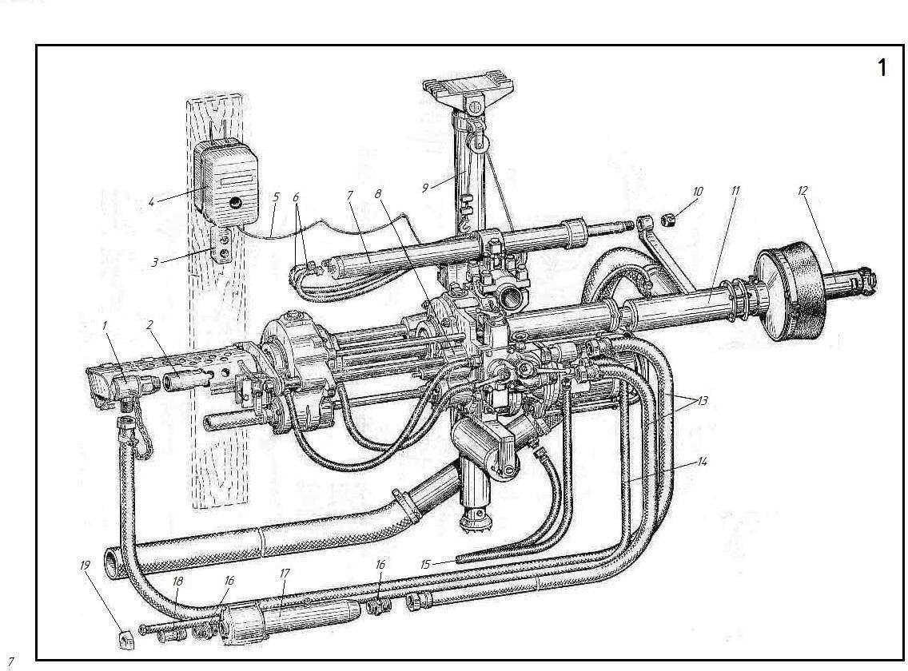

2 | НКP100MHА-0-0000 | Mašina za bušenje | Drilling machine
1 | НKР100МA-0-3000 | Spojnica | Coupling
2 | НKР100МA-0-1000 | Stalak za šipke | Rod column
3 | НKР100МA-0-9700 | Crevo | Hose
4 | НKР100МA-1-9100 | Pneumatski cilindar | Air cylinder
5 | НKР100МA-1-0000 | Mašina | Machine
6 | НKР100МA-2-5000 | Rasporni stub | Jack column
7 | НKР100МA-0-5100-03 | Crevo | Hose
8 | НKР100МA-1-0030 | Kapica matica | Cap nut
9 | НKР100МA-1-9000 | Odvod mulja | Sludge remover
10 | Пневмоударник | Pneumatski udarni čekić | Pneumatic striker
11 | НKР100МA-0-0010 | sakupljac | Collector
12 | НKР100МA-0-4000A | Crevo | Hose
13 | НKР100МA-0-5100-08 | Crevo | Hose
14 | НKР100МA-0-0001 | unija | Union
15 | Dy-20 | Zeporni ventil | Shut-off valve
16 | НKР100МПA-1-4000A | Crevo | Hose
17 | НKР100МA-0-5100-02 | Crevo | Hose
18 | НKР100МA-0-3058 | unija | Union
19 | HKP100MA-2-8000 | Filter-automatski podmazivač | Self-actingfilter-lubricator
20 | HKP100MПA-1-6000 | Prigušivač | Muffler
21 | HKP100MA-0-5101-02 | Nipel | Nipple
22 | HKP100MA-0-4001 | Navrtka | Coupling nut

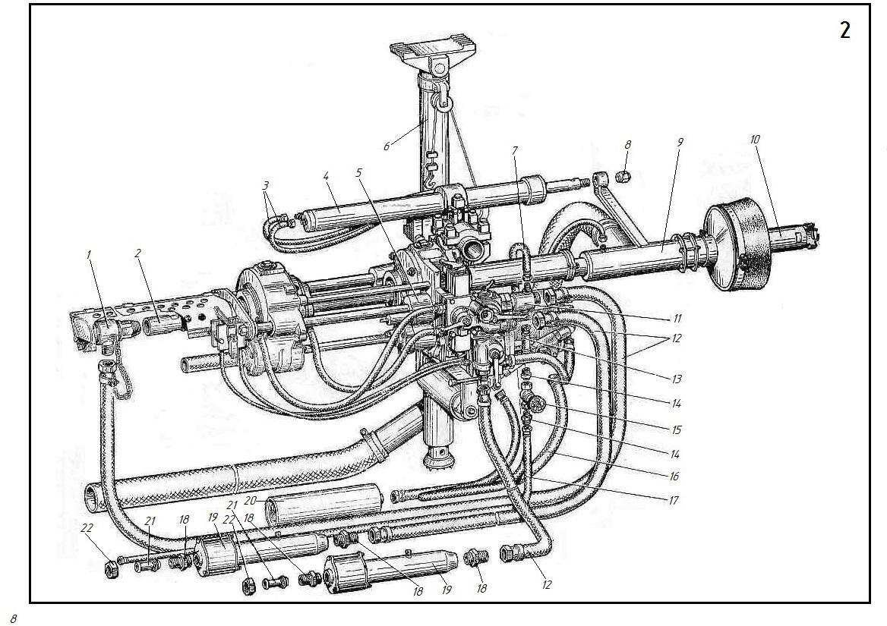
3 | НKP100MВА-0-0000 | Mašina za bušenje | Drilling machine
1 | HKP100MA-0-9700 | Crevo | Hose
2 | HKP100MA-1-9100 | Pneumatski cilindar | Air cylinder
3 | HKP100MBA-1-0000 | Mašina | Machine
4 | HKP100MA-1-0030 | Kapica matica | Cap nut
5 | HKP100MBA-2-0000 | Dizalica stub | Jack column
6 | Пневмоударник | Pneumatski udarni čekić | Pneumatic striker
7 | HKP100MA-1-9000 | Odvod mulja | Sludge remover
8 | HKP100MA-0-4000A | Crevo | Hose
9 | HKP100MA-0-5100-02 | Crevo | Hose
10 | HKP100MA-0-5100-03 | Crevo | Hose
11 | KГ 2х1,5 | Kabl | Cable
12 | 2491.ПMЕ-232 | Magnetni starter | Magnetic starter
13 | 2492.ПKЕ-222-2У2 | Dugme za upravljanje | Control button
14 | HKP100MA-0-3000 | Spojnica | Coupling
15 | HKP100MA-0-1000 | Stalak za šipke | Rod column
16 | HKP100MA-0-3058 | unija | Union
17 | HKP100MA-2-8000 | Filter-automatski podmazivač | Self-actingfilter-lubricator
18 | HKP100MA-0-5101-02 | Nipel | Nipple
19 | HKP100MA-0-4001 | Navrtka | Coupling nut

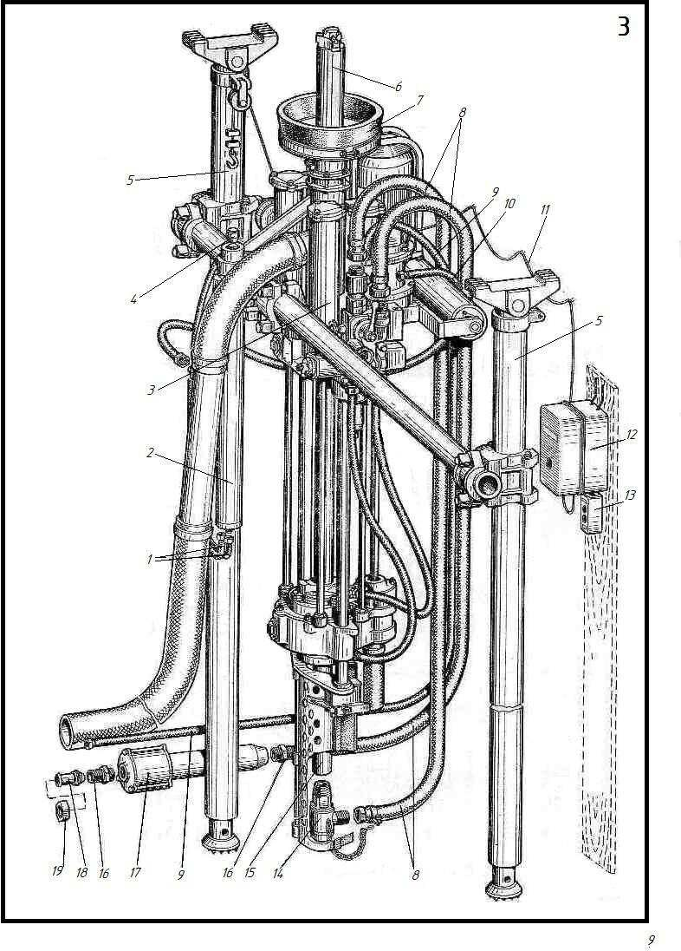

4 | НKP100MВHА-0-0000 | Mašina za bušenje | Drilling machine
1 | HKP100MA-0-9700 | Crevo | Hose
2 | HKP100MA-1-9100 | Pneumatski cilindar | Air cylinder
3 | HKP100MA-0-5100-03 | Crevo | Hose
4 | HKP100MBA-1-0000 | Mašina | Machine
5 | HKP100MA-1-0030 | Kapica matica | Cap nut
6 | HKP100MBA-2-0000 | Dizalica stub | Jack column
7 | Пневмоударник | Pneumatski udarni čekić | Pneumatic striker
8 | HKP100MA-1-9000 | Odvod mulja | Sludge remover
9 | HKP100MA-0-4000A | Crevo | Hose
10 | HKP100MA-0-0010 | sakupljac | Collector
11 | HKP100MA-0-5100-08 | Crevo | Hose
12 | HKP100MA-0-0001 | unija | Union
13 | Dy-20 | Zatvarajući ventil | Shut-off valve
14 | HKP100MA-0-3058 | unija | Union
15 | HKP100MA-0-1000 | Stalak za šipke | Rod column
16 | HKP100MA-0-3000 | Spojnica | Coupling
17 | HKP100MA-2-8000 | Filter-automatski podmazivač | Self-actingfilter-lubricator
18 | HKP100MПA-1-4000A | Crevo | Hose
19 | HKP100MA-0-5101-02 | Nipel | Nipple
20 | HKP100MПA-1-6000 | Prigušivač | Muffler
21 | HKP100MA-0-4001 | Navrtka | Coupling nut
22 | HKP100MA-0-5100-02 | Crevo | Hose
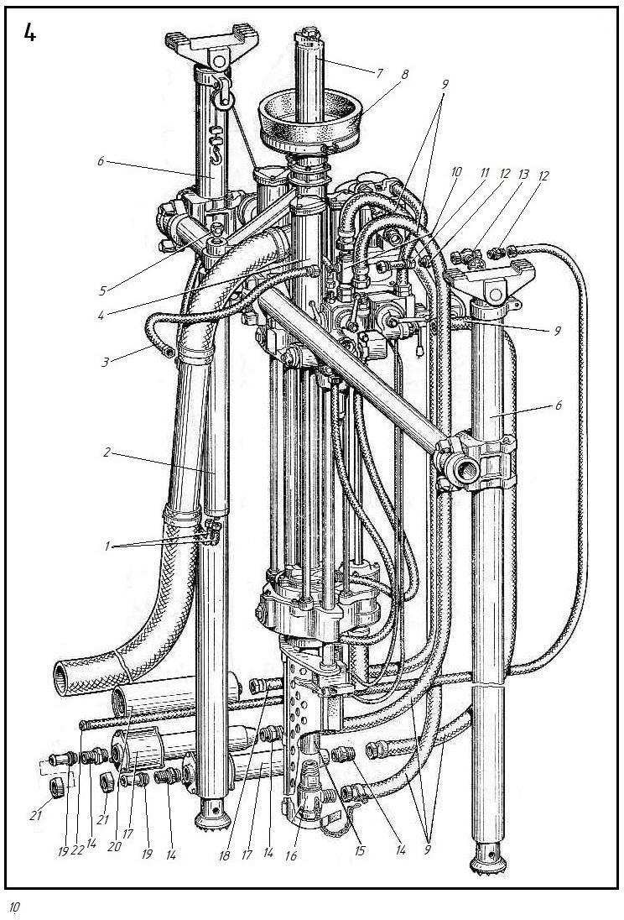
5 | NKR100MА-1-0000 | Mašina | Machine
1 | NKR100MA-1-1000 | Kartridž za hranjenje | Feeding chuck
2 | 5915.M24 | Navrtka | Nut
3 | 397.4х36-001 | Rascepka | Cotter pin
4 | 5915.M16 | Navrtka | Nut
5 | 6402.16 65G | Podloška | Washer
6 | 34-01-76.100х63 | Tabla | Plate
7 | 17476.M3х 8 | Sraf | Screw
8 | HKP100MA-0-0601 | Osnova Nosaca | Bracket base
9 | HKP100MA-0-0604 | Osovina | Axle
10 | HKP100MA-0-0602 | Poklopac | Cover
11 | БA100K-2-4-0 | Gajka sa kapicom | Cap nut
12 | 11371.24.02.21 | Podloška | Washer
13 | HKP100MA-0-0603 | Zglobni vijak | Swing bolt
14 | 397.3х20-001 | Rascepka | Cotter pin
15 | 11371.12.02.21 | Podloška | Washer
16 | NKR100-1-0005 | Dijafragma | Gasket
17 | NKR100M-1-0001-01 | Zavrtanj | Bolt
18 | NKR100MA-1-4000 | Podavac | Feeder
19 | NKR100M-1-0001 | Zavrtanj | Bolt
20 | NKR100M-1-0019 | Zavrtanj | Bolt
21 | NKR100MA-1-0800 | kutija | Housing
22 | Elektromotor | Elektromotor | Electric motor
23 | 7796.M14х45 | Zavrtanj | Bolt
24 | 6402.14 65G. 01.21 | Podloška | Washer
25 | 5915.M14 | Navrtka | Nut
26 | 7796.M16х100 | Zavrtanj | Bolt
27 | 6402.12 65G | šajba | Washer
28 | 5915.M12 | Gajka | Nut
29 | NKR100MA-1-3000 | Kontrolna table | Control panel
30 | 7796.M12х85 | Zavrtanj | Bolt
31 | NKR100MA-1-0700 | Valjak | Roller
32 | 18143.1,5-Т-12х18N10Т | Žica | Wire
33 | 7796.M20х40 | Zavrtanj | Bolt
34 | NKR100MA-1-2000 | Pnevmoredukcija | Reducer with pneumatic clamp
35 | NKR100MA-0-5100 | Crevo | Hose
36 | NKR100MA-0-5100-01 | Crevo | Hose
37 | NKR100MA-1-0030 | Gajka sa kapicom | Cap nut

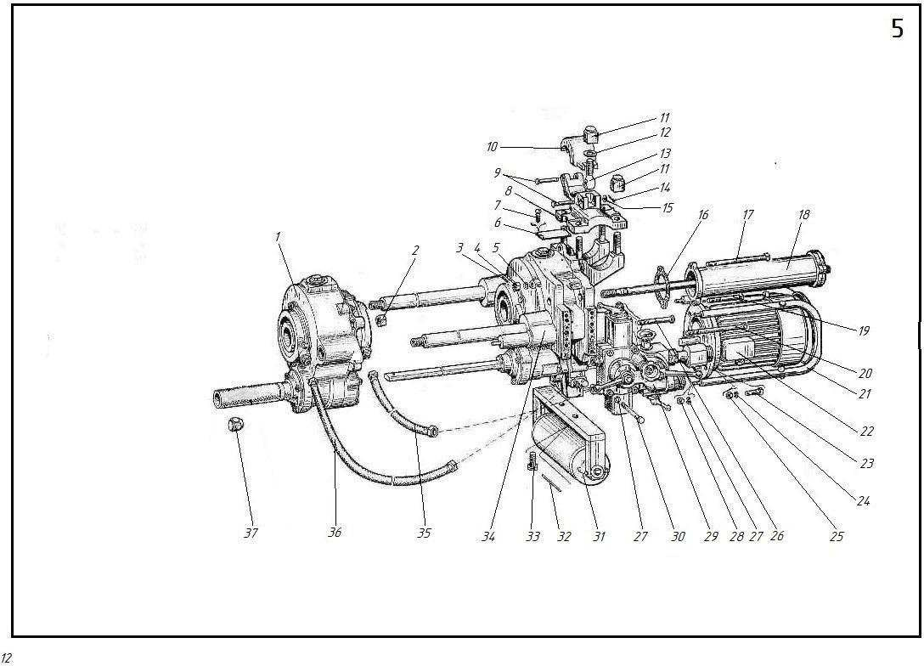

6 | НKP100MHА-1-0000 | Mašina | Machine
1 | HKP100MA-1-1000 | Kartridž za hranjenje | Feeding chuck
2 | 5915.M24 | Navrtka | Nut
3 | 397.4х36-001 | Rascepka | Cotter pin
4 | 5915.M16 | Navrtka | Nut
5 | 6402.16 65Г | Podloška | Washer
6 | 17473.M3х 8 | Sraf | Screw
7 | 34-01-76.100х63 | Tabla | Plate
8 | HKP100MA-0-0604 | Osovina | Axle
9 | HKP100MA-0-0602 | Poklopac | Cover
10 | БA100K-2-4-0 | Gajka sa kapicom | Cap nut
11 | 11371.24.02.21 | Podloška | Washer
12 | HKP100MA-0-0603 | Zglobni vijak | Swing bolt
13 | 397.3х20-001 | Rascepka | Cotter pin
14 | 11371.12.02.21 | Podloška | Washer
15 | HKP100MA-0-0601 | Osnova Nosaca | Bracket base
16 | HKP100-1-0005 | Dijafragma | Gasket
17 | HKP100M-1-0001-01 | Zavrtanj | Bolt
18 | HKP100MA-1-4000 | Podavac | Feeder
19 | HKP100M-1-0001 | Zavrtanj | Bolt
20 | 7796.M16х100 | Zavrtanj | Bolt
21 | HKP100M-1-0019 | Zavrtanj | Bolt
22 | HKP100MП-1-0200 | koleno | Knee
23 | 10362.32K43-16 | Crevo | Hose
24 | HKP100MП-1-0002 | unija | Union
25 | HKP100MПA-1-3000 | Kontrolna table | Control panel
26 | HKP100MПA-1-4200A | Crevo | Hose
27 | 7796.M12х85 | Zavrtanj | Bolt
28 | 6402.12 65Г | Podloška | Washer
29 | 7796.M8х80 | Zavrtanj | Bolt
30 | HKP100MA-2-3058 | unija | Union
31 | HKP100MП-1-0004 | T račva | T-joint
32 | HKP100MП-1-0003 | Dijafragma | Gasket
33 | HKP100MA-1-0700 | Valjak | Roller
34 | 18143.1,5-Т-12х18H10Т | Zica | Wire
35 | 7796.M20х40 | Zavrtanj | Bolt
36 | HKP100MПA-2-2000* | Pnevmoredukcija | Reducer with air motor
37 | HKP100MA-0-5100-01 | Crevo | Hose
38 | HKP100MA-0-5100 | Crevo | Hose
39 | HKP100MA-1-0030 | Gajka sa kapicom | Cap nut

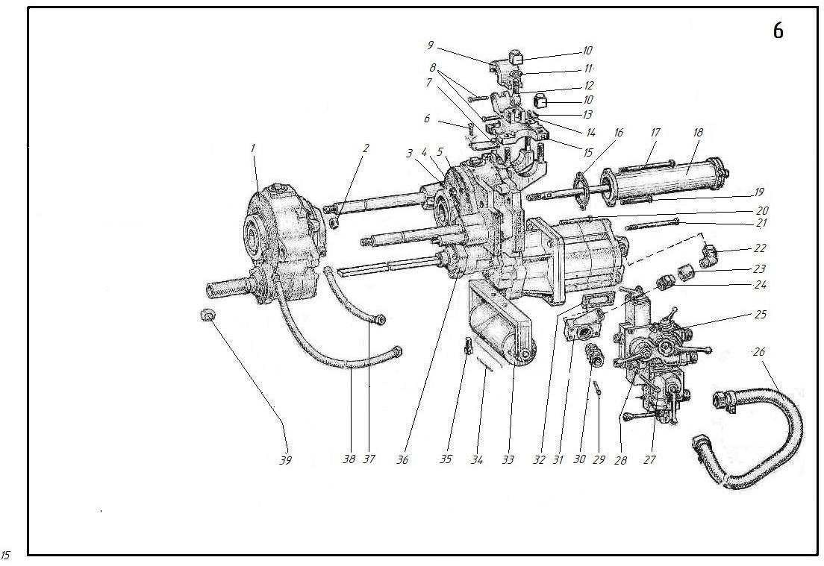

7 | НKP100MВА-1-0000 | Mašina | Machine
1 | HKP100MA-1-1000-01 | Kartridž za hranjenje | Feeding chuck
2 | 5915.M24 | Navrtka | Nut
3 | 397.4х36-001 | Rascepka | Cotter pin
4 | 5915.16 | Navrtka | Nut
5 | 6402.16 65Г | Podloška | Washer
6 | 34-01-76.100х63 | Tabla | Plate
7 | 1476.M3х 8 | Sraf | Screw
8 | HKP100MA-0-0601 | Osnova Nosaca | Bracket base
9 | HKP100MA-0-0602 | Osovina | Axle
10 | HKP100MA-0-0604 | Poklopac | Cover
11 | БA100K-2-4-0 | Gajka sa kapicom | Cap nut
12 | 11371.24.02.21 | Podloška | Washer
13 | HKP100MA-0-0603 | Zglobni vijak | Swing bolt
14 | 397.3х20-001 | Pin | Cotter pin
15 | 11371.12.02.21 | Podloška | Washer
16 | HKP100-1-0005 | Dijafragma | Gasket
17 | HKP100M-1-0001-01 | Zavrtanj | Bolt
18 | HKP100MA-1-4000 | Podavac | Feeder
19 | HKP100M-1-0001 | Zavrtanj | Bolt
20 | HKP100MA-1-0800 | Kutija | Housing
21 | Электродвигатель | Elektromotor | Electric motor
22 | 7796.M14х45 | Zavrtanj | Bolt
23 | 6402.14 65Г | Podloška | Washer
24 | 5915.M14 | Gajka | Nut
25 | 6402.12 65Г | Podloška | Washer
26 | 5915.M12 | Gajka | Nut
27 | HKP100MA-1-3000 | Kontrolna table | Control panel
28 | 7796.M12х85 | Zavrtanj | Bolt
29 | HKP100MA-1-0700 | Valjak | Roller
30 | 18143.1,5-Т-12х18H10Т | Zica | Wire
31 | 7796.M20х40 | Zavrtanj | Bolt
32 | HKP100MA-1-2000-01 | Pnevmoredukcija | Reducer with pneumatic clamp
33 | HKP100MA-0-5100 | Crevo | Hose
34 | HKP100MA-0-5100-01 | Crevo | Hose
35 | HKP100MA-1-0030 | Gajka sa kapicom | Cap nut

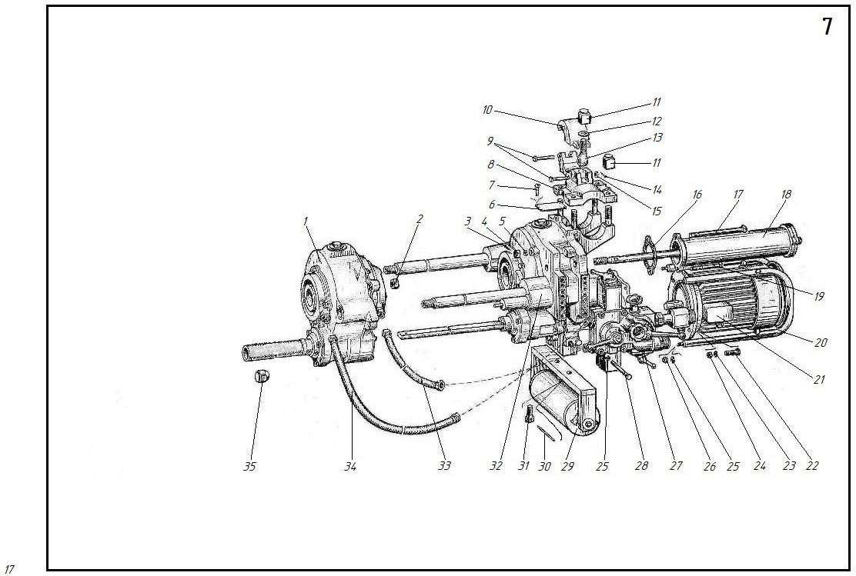

8 | НKP100MВHА-1-0000 | Mašina | Machine
1 | HKP100MA-1-1000 | Kartridž za hranjenje | Feeding chuck
2 | 5915.M24 | Navrtka | Nut
3 | 397.4х36-001 | Rascepka | Cotter pin
4 | 5915.M16 | Navrtka | Nut
5 | 6402.16 65Г | Podloška | Washer
6 | 17473.M3х 8 | Sraf | Screw
7 | 34-01-76.100х63 | Tabla | Plate
8 | HKP100MA-0-0602 | Osovina | Axle
9 | HKP100MA-0-0604 | Poklopac | Cover
10 | БA100K-2-4-0 | Gajka sa kapicom | Cap nut
11 | 11371.24.02.21 | Podloška | Washer
12 | HKP100MA-0-0603 | Zglobni vijak | Swing bolt
13 | 397.3х20-001 | Rascepka | Cotter pin
14 | 11371.12.02.21 | Podloška | Washer
15 | HKP100MA-0-0601 | Osnova Nosaca | Bracket base
16 | HKP100-1-0005 | Dijafragma | Gasket
17 | HKP100M-1-0001-01 | Zavrtanj | Bolt
18 | HKP100MA-1-4000 | Podavac | Feeder
19 | HKP100M-1-0001 | Zavrtanj | Bolt
20 | 7796.M16х100 | Zavrtanj | Bolt
21 | HKP100M-1-0019 | Zavrtanj | Bolt
22 | HKP100MП-1-0200 | koleno | Knee
23 | 10362.32K43-16 | Crevo | Hose
24 | HKP100MП-1-0002 | unija | Union
25 | HKP100MПA-1-3000 | Kontrolna table | Control раnеl
26 | HKP100MПA-1-4200A | Crevo | Hose
27 | 7796.M12х85 | Zavrtanj | Bolt
28 | 6402.12 65Г | Podloška | Washer
29 | 7796.M8х80 | Zavrtanj | Bolt
30 | HKP100MA-2-3058 | unija | Union
31 | HKP100MП-1-0004 | T račva | T-joint
32 | HKP100MП-1-0003 | Dijafragma | Gasket
33 | HKP100MA-1-0700 | Valjak | Roller
34 | 18143.1,5-Т-12х18H10Т | Zica | Wire
35 | 7796.M20х40 | Zavrtanj | Bolt
36 | HKP100MПA-2-2000* | Pnevmoredukcija | Reducer with air motor
37 | HKP100MA-0-5100-01 | Crevo | Hose
38 | HKP100MA-0-5100 | Crevo | Hose
39 | HKP100MA-1-0030 | Gajka sa kapicom | Cap nut
*Za\for HKP100MВПA-1-0000 (dr.17-1)

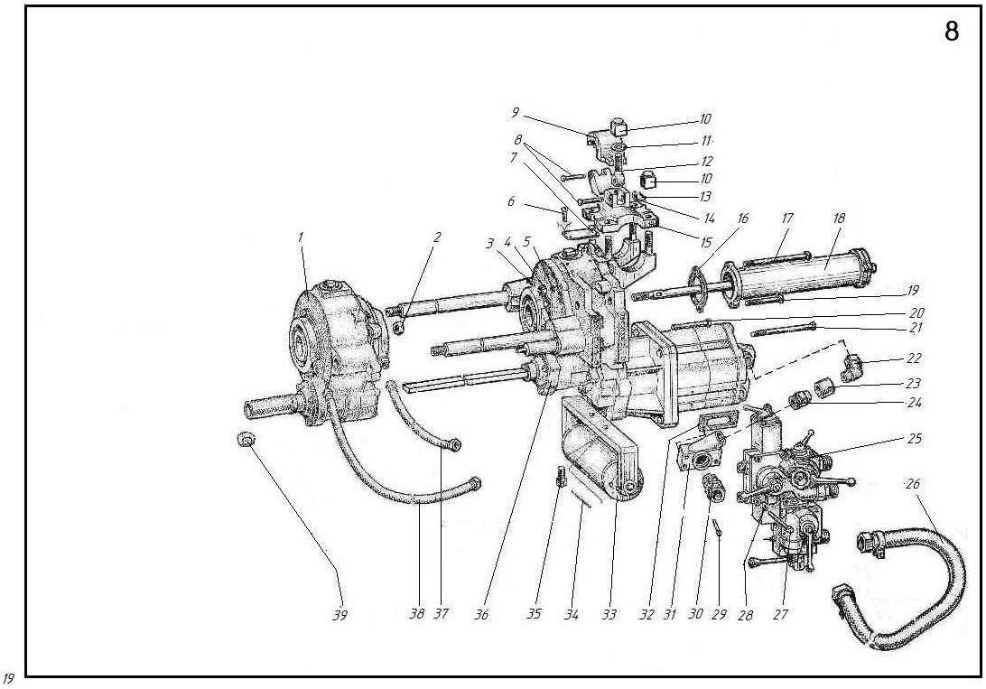

9 | НKP100MВА-2-0000 | Rasporni stub | Jack column
1 | HKP100MB-2-0001 | Cev | Pipe
2 | HKP100MB-2-1002 | Poklopac ovratnika | Collar cover
3 | 22032.M24X80 | Navojna šipka | Stud
4 | БA100K-2-4-0 | Gajka sa kapicom | Cap nut
5 | 7795.M24х90 | Zavrtanj | Bolt
6 | 3128.5h8х40 | Igl | Pin
7 | HKP100MBA-2-1001 | Kućište ovratnika | Collar case
8 | БA100K-2-0-14 | Osovina | Axle
9 | 11371.12.02.21 | Podloška | Washer
10 | 397.3х20-001 | Rascepka | Cotter pin
11 | БA100M-2-5-0 | Kavez valjka | Roller cage
12 | БA100K-2-0-8 | Valjak | Roller
13 | 9650.22-12х50.35.4.05.21 | Osovina | Axle
14 | 397.4х28-001 | Rascepka | Cotter pin
15 | 11371.20.02.21 | Podloška | Washer
16 | HKP100MA-1-5011 | Ovratnik | Collar
17 | БA100K-2-19-0 | Ručni vitlo | Hand winch
18 | БA100K-2-0-16 | Sigurnosna podloška | Lock washer
19 | 7795.M12х35 | Zavrtanj | Bolt
20 | HKP100MA-1-5012 | Osovina | Axle
21 | HKP100MA-2-5040-02 | Cev | Pipe
22 | БA100M-2-2-0 | šraf | Screw
23 | БA100M-2-3-3 | Poluprsten | Half-ring

10 | НKP100MА-1-0700 | Valjak | Roller
1 | 397.2,5х25.001 | Rascepka | Cotter pin
2 | 5915.M10 | Navrtka | Nut
3 | 11371.10.021 | Podloška | Washer
4 | HKP100MA-1-0710 | Nosač | Bracket
5 | HKP100MA-1-0702 | Čaura | Bushing
6 | HKP100MA-1-0706 | Veza | Tie
7 | 7796.M8х16 | Zavrtanj | Bolt
8 | 6402.10 65Г | Podloška | Washer
9 | 9833.025-031-30-2-2 | Prsten | Ring
10 | HKP100MA-1-0701 | Poklopac | Cover
11 | HKP100MA-1-0705 | Zaptivka | Gasket
12 | 8338.205 | Ležaj | Bearing
13 | HKP100MA-1-0707 | Kućište ležaja | Bearing case
14 | 9833.030-035-30-2-2 | Prsten | Ring
15 | HKP100MA-1-0703 | Osovina | Shaft
16 | HKP100MA-1-0704 | Zavrtanj | Bolt
17 | HKP100MA-1-0720 | Bubanj | Drum
11 | НKP100MА-1-0800 | Kućište | Housing
1 | HKP100MA-1-0805 | Rascepka | Cotter pin
2 | HKP100MA-1-0810 | Ram | Frame
3 | 397.1,6х12-001 | Rascepka | Cotter pin
4 | 5915.M8 | Navrtka | Nut
5 | HKP100MA-1-0804 | Čaura | Bushing
6 | 7796.M8х50 | Zavrtanj | Bolt

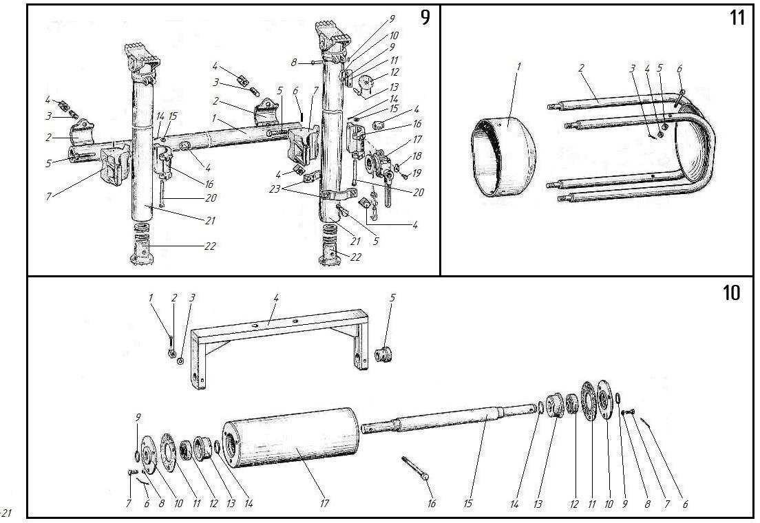

12 | НKP100MА-1-1000 | Glava za hranjenje | Feeding chuck
1 | HKP100-1-1017 | Distancioni prsten | Spacer ring
2 | HKP100M-1-1038 | Ekscentrik | Cam
3 | 5915.M12.8.029 | Navrtka | Nut
4 | 6402.12 65Г | Podloška | Washer
5 | 6969.130х160 | Zaptivka čaše | Cup packing
6 | HKP100M-1-1034K | Regulacioni prsten | Adjusting ring
7 | HKP100M-1-1025 | Zaptivka | Gasket
8 | HKP100M-1-1035 | Poklopac | Cover
9 | 1476.M6х16. | Zavrtanj | Screv
10 | HKP100M-1-1024 | Vijak | Stud
11 | HKP100MA-1-1012 | Čaura | Bushing
12 | HKP100M-1-1037 | Čep | Plug
13 | HKP100MA-1-1016 | Kućište | Body
14 | 22032M12х25 | Vijak | Stud
15 | 8338.226 | Ležaj | Bearing
16 | 18143.1,6-Т-12х18H10Т | Žica | Wire
17 | 7796.10х16 | Zavrtanj | Bolt
18 | 9833.100-110-58-2-2 | Prsten | Ring
19 | HKP100M-1-1020 | Klip | Piston
20 | 6969.90х120 | Zaptivka čaše | Cup packing
21 | HKP100M-1-1031 | Zupčanik | Gear wheel
22 | HKP100M-1-1032 | Čaura | Bushing
23 | HKP100M-1-1033 | Čaura | Bushing
24 | 3128.10h8х30 | Igl | Pin
25 | 3128.5h8х10 | Igl | Pin
26 | HKP100MA-1-1067 | Navojna čaura | Threaded bushing
27 | HKP100M-1-1036K | Čaura | Bushing
28 | HKP100M-1-1003 | Zaptivka | Gasket
29 | HKP100M-1-1002 | Poklopac | Cover
30 | 7796.M12х20 | Zavrtanj | Bolt
31 | HKP100M-1-3005 | unija | Union
32 | HKP100M-1-1026A | Poklopac | Cover
33 | HKP100M-1-1030 | Zaptivka | Gasket
34 | 8752.1-50х70-2 | Zaptivka čaše | Cup packing
35 | 8338.310 | Ležaj | Bearing
36 | HKP100M-1-1071 | Poklopac | Cover
 | HKP100M-1-1071-01 | Poklopac | Cover
37 | HKP100M-1-1008 | Zaptivka | Gasket
38 | HKP100M-2-1072 | Zupčanik | Gear
39 | HKP100M-1-1040 | Prsten | Ring
40 | HKP100M-1-1018 | Poklopac | Cover
41 | HKP100M-1-1028 | Čaura | Bushing
42 | 17475.2M12х25 | Zavrtanj | Screw
43 | 22032.M12х80 | Vijak | Stud
44 | 16-02-78.14 | Podloška | Washer
45 | 16-0178.M14х1,5 | Čep | Plug
46 | 3128.3h8х18 | Igl | Pin
47 | 22032.M12х25 | Vijak | Stud
48 | HKP100M-1-1100 | Međuosovina | Intermediate shaft
49 | HKP100M-1-1019A | Poklopac | Cover
50 | HKP100M-1-1021 | Čaura | Sleeve

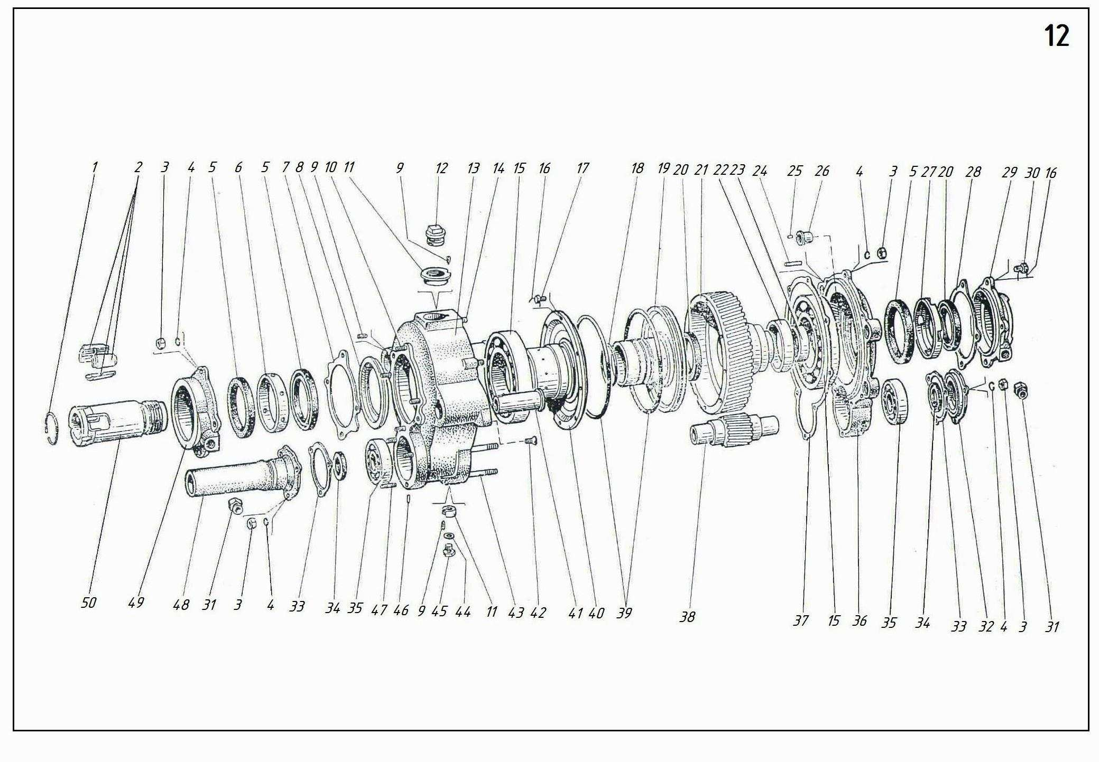

13 | НKP100MА-0-1020 | Separator za gas i tečnost | Gas-and-fluid separator
1 | HKP100MA-0-1021 | Separator štap | Separator rod
2 | HKP100MA-0-1030 | Zavrtanj | Serew
3 | HKP100M-0-1022 | Filter | Filter
4 | HKP100M-0-1023 | Adapter | Adapter

14 | НKP100M-1-1300 | Račna ključ | Ratchet -Wrench
1 | HKP100M-1-0010 | Držač | Retainer
2 | БA100M-1-16-29 | Opruga | Spring
3 | HKP100M-1-0008 | Ručka | Handle
4 | HKP100M-1-0007 | Opružni prsten | Spring ring
5 | HKP100M-1-0009 | Čaura | Bushing

15 | НKP100MА-0-3000 | Spojnica | Coupling
1 | HKP100M-0-2001 | Navrtka | Nut
2 | HKP100M-0-2003 | Prsten | Ring
3 | 6969.50х70 | Zaptivka čaše | Cup packing
4 | HKP100M-0-3100 | Kućište | Body
5 | HKP100M-0-2200 | Nipel | Nipple

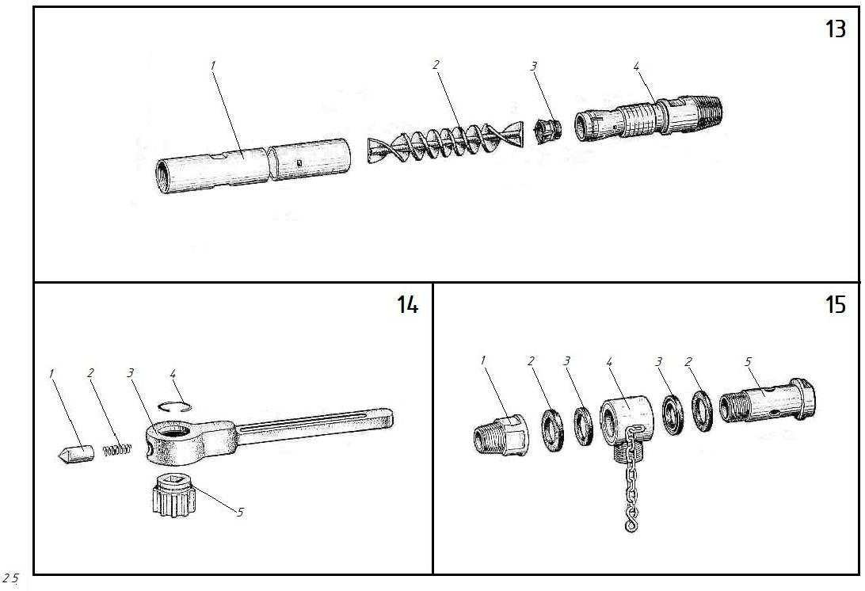

16 | НKP100MА-1-2000 | Reduktor sa pneumatskom stegom | Reducer with Pneumatic Clamp
 | НKP100MВА-1-2000*
1 | HKP100M-1-1031 | Zupčanik | Gear wheel
2 | 8338.226 | Ležaj | Bearing
3 | HKP100M-1-2039 | Poklopac | Cover
4 | HKP100M-1-1032 | Čaura | Bushing
5 | 6969.130х160 | Zaptivka čaše | Cup packing
6 | HKP100M-1-1036K | Čaura | Bushing
7 | 6969.90х120 | Zaptivka čaše | Cup packing
8 | 7796.M10х45 | Zavrtanj | Bolt
9 | 18143-Т-12X18H10Т | Žica | Wire
10 | HKP100M-1-2083 | Poklopac | Cover
11 | HKP100M-1-2084 | Zaptivka | Gasket
12 | HKP100M-1-2032 | Opruga | Spring
13 | HKP100M-1-2400A | Ventil | Valve
14 | 9833.032-040-46-2-2 | Prsten | Ring
15 | HKP100M-1-2034 | Kućište ventila | Valve body
16 | HKP100M-1-1033 | Čaura | Bushing
17 | HKP100MA-1-2500 | Poklopac | Cover
 | HKP100MA-1-2500A | Poklopac | Cover
18 | HKP100MA-1-2025 | Vijak | Stud
19 | 7796.M12х50 | Zavrtanj | Bolt
20 | 3128.8h8х40 | Igl | Pin
21 | HKP100M-1-2018 | Zaptivka | Gasket
22 | HKP100M-1-2001 | Poklopac | Cover
23 | 6402.10 65Г | Podloška | Washer
24 | 7796.M10х25 | Zavrtanj | Bolt
25 | 6969.25х45 | Zaptivka čaše | Cup packing
26 | HKP100-1-2016 | Zaptivka | Gasket
27 | HKP100M-1-2016 | Nosač | Carrier
28 | 8338.208 | Ležaj | Bearing
29 | HKP100-1-2077 | Igl | Pin
30 | HKP100M-1-2092A | Čep | Stopper
31 | HKP100M-1-2086 | Sunčani zupčanik | Sun gear
32 | 8752.1-40х60-2 | Zaptivni prsten | Packing ring
33 | HKP100M-1-2015 | Krunski zupčanik | Crown gear
34 | 397.2,5х25-001 | Rascepka | Colter pin
35 | 5915.M10 | Navrtka | Nut
36 | HKP100M-1-2080 | Vijak | Stud
37 | HKP100M-1-2802 | Prirubnica | Flange
38 | HKP100M-1-2801 | Čaša | Cup
39 | HKP100M-1-2056 | Čaura | Bushing
40 | HKP100M-1-2027 | Klepet | Tappet
41 | HKP100M-1-2054 | Opruga | Spring
42 | HKP100M-1-2053 | Čaura | Sleeve
43 | HKP100M-1-2024 | Kućište ventila | Valve body
44 | 7796.M12X85 | Zavrtanj | Bolt
45 | HKP100MA-1-2720 | Adapter | Adapter
46 | 5915.M10 | Navrtka | Nut
47 | HKP100M-1-2711 | Poluspojka | Half-coupling
48 | HKP100M-1-2712 | Poluspojka | Half-coupling
49 | HKP100M-1-2715 | Elastična čaura | Elastic bushing
50 | HKP100M-1-2714 | Igl | Pin
51 | HKP100M-1-2716 | Distanciona čaura | Distance bushing
52 | 8789.8X7X40 | Ključ | Key
53 | 6402.12 65Г | Podloška | Washer
54 | 5915.M12 | Navrtka | Nut
55 | HKP100MA-1-1037 | Čep | Plug
56 | 1476.M6X16 | Vijak | Screw
57 | HKP100MA-1-1012 | Čaura | Bushing
58 | HKP100M-1-2020 | Zaptivka | Gasket
59 | 7796.M10X16 | Zavrtanj | Bolt
60 | HKP100M-1-1018 | Poklopac | Cover
61 | HKP100M-1-1040 | Prsten | Ring
62 | 9833.100-110-58-2-2 | Prsten | Ring
63 | HKP100M-1-1020 | Klip | Piston
64 | HKP100MA-1-2028 | Vođica | Guide
65 | HKP100-1-2076 | Vijak | Stud
66 | HKP100-1-2063 | Zaptivka | Gasket
67 | HKP100MA-1-2900 | Kućište | Body
 | HKP100MA-1-2900-01 | Kućište | Body
68 | 7796.M12X35 | Zavrtanj | Bolt
69 | 3128.3h8X18 | Igl | Pin
70 | 22036.M12X25 | Vijak | Stud
71 | 8752.1 50X70-2 | Zaptivka čaše | Cup packing
72 | HKP100M-1-1030 | Zaptivka | Gasket
73 | HKP100M-1-1035 | Poklopac | Cover
74 | HKP100M-1-2004A | Poklopac | Cover
75 | HKP100M-2-2007 | Igl | Pin
76 | HKP100M-2-2005 | Adapter | Adapter
77 | HKP100M-2-2006 | Čaura | Bushing
78 | HKP100M-2-2002 | Opružni prsten | Spring ring
79 | HKP100M-2-2008 | Međuosovina | Intermediate shaft
80 | HKP100M-1-1024 | Vijak | Stud
81 | 22036.M12X45 | Vijak | Stud
82 | HKP100M-1-1021 | Čaura | Sleeve
83 | HKP100-1-1017 | Distancioni prsten | Spacer ring
84 | HKP100M-1-1038 | Ekscentrik | Cam
85 | 8338.310 | Ležaj | Bearing
86 | HKP100M-1-2003 | Distanciona čaura | Distance bushing
87 | HKP100M-1-2038 | Zupčanik | Gear
88 | HKP100M-1-2002 | Opružni prsten | Spring ring
89 | 7796.M12X150 | Zavrtanj | Bolt
90 | 16-02-78.14 | Podloška | Washer
91 | HKP100M-1-2079 | Uzemo za uzemljenje | Earthed stud
92 | БA100M-1-0-39 | Oblikovana podloška | Shaped washer
93 | 16-01-78.M14X1,5 | Čep | Plug
94 | HKP100-1-2068 | Zaptivka | Gasket
95 | HKP100M-1-2300A | Poklopac | Cover
96 | HKP100M-1-1034K | Regulacioni prsten | Adjusting ring
97 | HKP100-1-2013 | Podloška | Washer
98 | 8338.304 | Ležaj | Bearing
99 | HKP100M-1-2011 | Planetarni zupčanik | Planetary gear
100 | HKP100M-1-2035 | Opružni prsten | Spring ring
101 | 397. 5X40-001 | Rascepka | Cotter pin
102 | HKP100M-1-2019 | Zaptivka | Gasket

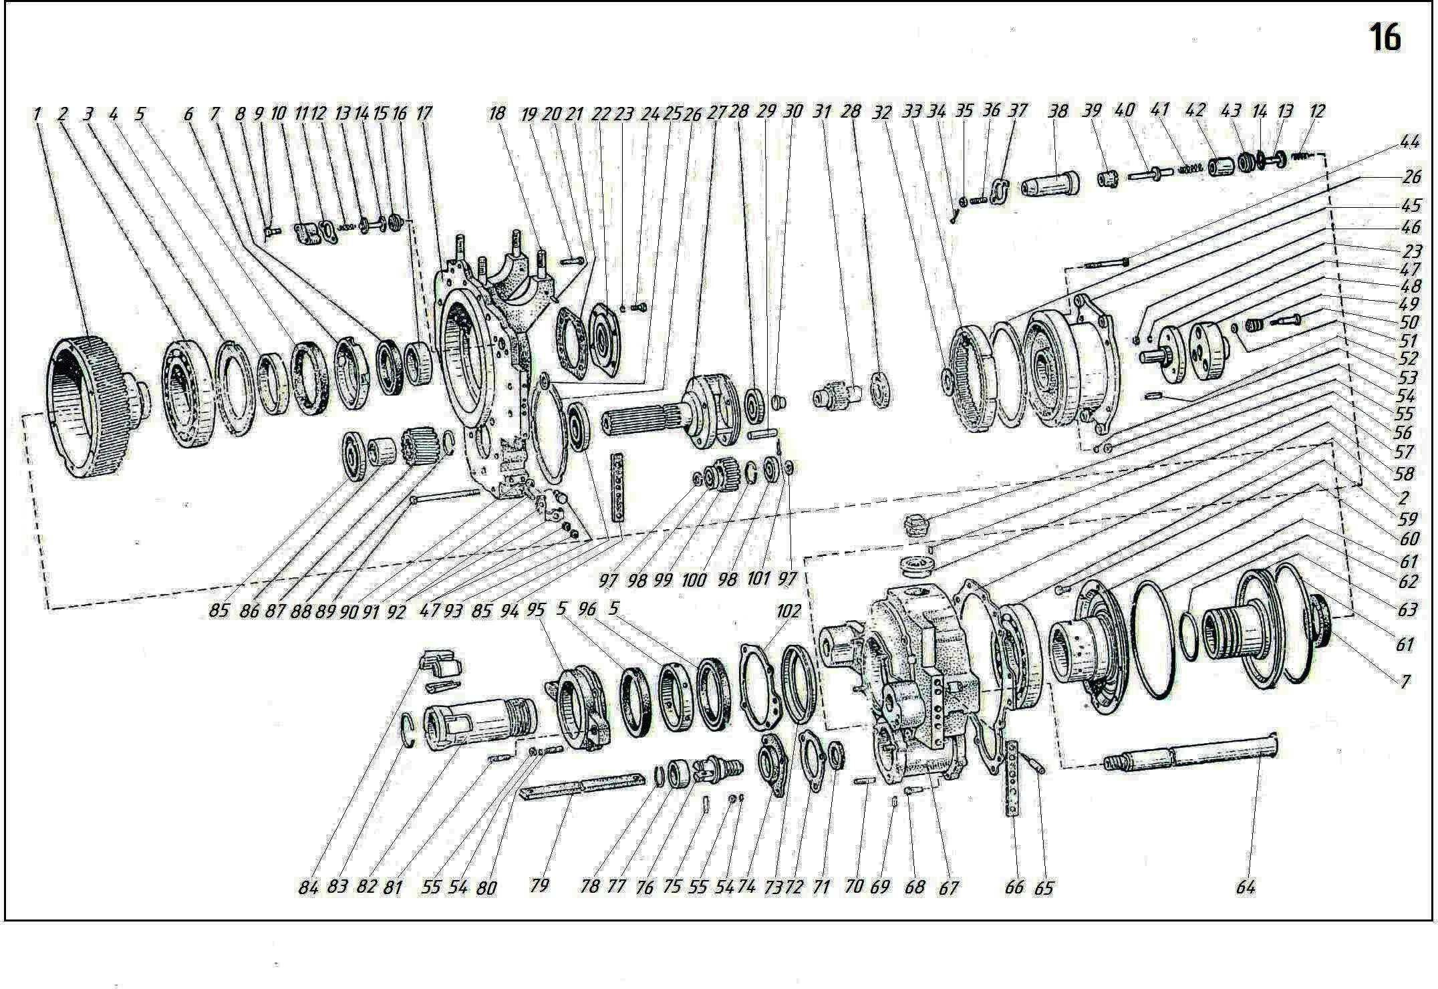

17 | НKP100MHА-1-2000 | Reduktor sa pneumatskom stegom | Reducer with Pneumatic Clamp
 | НKP100MВHА-2000
1 | HKP100M-1-1031 | Zupčanik | Gear wheel
2 | 8338.226 | Ležaj | Bearing
3 | HKP100M-1-2039 | Poklopac | Cover
4 | HKP100M-1-1032 | Čaura | Bushing
5 | 6969.130X160 | Zaptivka čaše | Cup packing
6 | 7796.M10X45 | Zavrtanj | Bolt
7 | 18143.2-Т-12X18H10Т | Žica | Wire
8 | HKP100M-1-2083 | Poklopac | Cover
9 | HKP100M-1-2084 | Zaptivka | Gasket
10 | HKP100M-1-2032 | Opruga | Spring
11 | 6969.90X120 | Zaptivka čaše | Cup packing
12 | HKP100M-1-2400A | Ventil | Valve
13 | 9833.032-040-46-2-2 | Prsten | Ring
14 | HKP100M-1-2034 | Kućište ventila | Valve body
15 | HKP100M-1-1033 | Čaura | Bushing
16 | HKP100MA-1-2500 | Poklopac | Cover
17 | HKP100MA-1-2500A | Poklopac | Cover
18 | HKP100MA-1-2025 | Vijak | Stud
19 | 7796.M12X50 | Zavrtanj | Bolt
20 | 3128.8h8X40 | Igl | Pin
21 | HKP100M-1-2018 | Zaptivka | Gasket
22 | HKP100M-1-2001 | Poklopac | Cover
23 | 6402.10 65Г | Podloška | Washer
24 | 7796.M10X25 | Zavrtanj | Bolt
25 | 6969.25X45 | Zaptivka čaše | Cup packing
26 | HKP100MП-1-2041 | Pionir šlem | Pinion slem
27 | HKP100MП-1-2600 | Prirubnica | Flange
28 | 7796.M12X35 | Zavrtanj | Bolt
29 | 7796.M12X50 | Zavrtanj | Bolt
30 | HKP100MП-1-2009 | Pionir šlem | Pinion slem
31 | 13941.1A110 | Prsten | Ring
32 | 8338.310 | Ležaj | Bearing
33 | 397.2,5X25-001 | Rascepka | Colter pin
 | 5915.M10 | Navrtka | Nut
34 | HKP100M-1-2080 | Vijak | Stud
35 | HKP100M-1-2802 | Prirubnica | Flange
36 | HKP100MП-1-2014 | Čaura | Bushing
37 | HKP100M-1-2801 | Čaša | Cup
38 | 7796.M16X65 | Zavrtanj | Bolt
39 | HKP100M-1-2056 | Čaura | Bushing
40 | HKP100M-1-2027 | Taster | Tappet
41 | HKP100M-1-2054 | Opruga | Spring
42 | HKP100M-1-2053 | Čaura | Sleeve
43 | HKP100M-1-2024 | Kućište ventila | Valve body
44 | HKP100MП-1-2012 | Zaptivka | Gasket
45 | 13940.1A50 | Prsten | Ring
46 | HKP100MП-1-2015 | Među telo | Intermediate bodi
47 | 6969.50X70 | Zaptivka čaše | Cup packing
48 | 397.3X32-001 | Rascepka | Colter pin
49 | 1476.M6X16 | Vijak | Screw
50 | HKP100MA-1-1012 | Čaura | Bushing
51 | 7796.M10X16 | Zavrtanj | Bolt
52 | HKP100M-1-1040 | Prsten | Ring
53 | HKP100M-1-1020 | Klip | Piston
54 | 9833.100-110-58-2-2 | Prsten | Ring
55 | HKP100MA-1-2028 | Vođica | Guide
56 | HKP100M-1-1018 | Poklopac | Cover
57 | HKP100-1-2076 | Vijak | Stud
58 | HKP100-1-2063 | Zaptivka | Gasket
59 | HKP100M-1-2020 | Zaptivka | Gasket
60 | 7796.M12X35 | Zavrtanj | Bolt
61 | 3128.3h8X18 | Igl | Pin
62 | HKP100MA-1-2900 | Kućište | Body
 | HKP100MA-1-2900-01 | Kućište | Body
63 | 22032.M12X25 | Vijak | Stud
64 | 8752.1 50X70-2 | Zaptivka čaše | Cup packing
65 | HKP100M-1-1030 | Zaptivka | Gasket
66 | HKP100M-1-2004A | Poklopac | Cover
67 | 6402.12 65Г | Podloška | Washer
68 | 5915.M12 | Navrtka | Nut
69 | HKP100M-2-2007 | Igl | Pin
70 | HKP100M-2-2005 | Adapter | Adapter
71 | HKP100M-2-2006 | Čaura | Bushing
72 | HKP100M-2-2002 | Opružni prsten | Spring ring
73 | HKP100M-2-2008 | Međuosovina | Intermediate shaft
74 | HKP100M-1-1024 | Vijak | Stud
75 | 22032.M12X45 | Vijak | Stud
76 | HKP100-1-1017 | Distancioni prsten | Spacer ring
77 | HKP100M-1-1036K | Čaura | Bushing
78 | HKP100M-1-2003 | Distanciona čaura | Distance bushing
79 | HKP100M-1-2038 | Zupčanik | Gear
80 | HKP100M-1-2002 | Opružni prsten | Spring ring
81 | HKP100M-1-1038 | Ekscentrik | Cam
82 | HKP100M-1-1021 | Čaura | Sleeve
83 | 16-02-78.14 | Podloška | Washer
84 | 16-01-78.M14X1,5 | Čep | Plug
85 | HKP100M-1-2300A | Poklopac | Cover
86 | HKP100MП-1-2004 | Zaptivka | Gasket
87 | HKP100-1-2068 | Zaptivka | Gasket
88 | HKP100M-1-1034K | Regulacioni prsten | Adjusting ring
89 | 7796.M12X75 | Zavrtanj | Bolt
90 | HKP100M-1-2019 | Zaptivka | Gasket
91 | 5915.M12 | Navrtka | Nut
92 | HKP100M-1-1035 | Poklopac | Cover
93 | HKP100MA-1-1037 | Čep | Plug

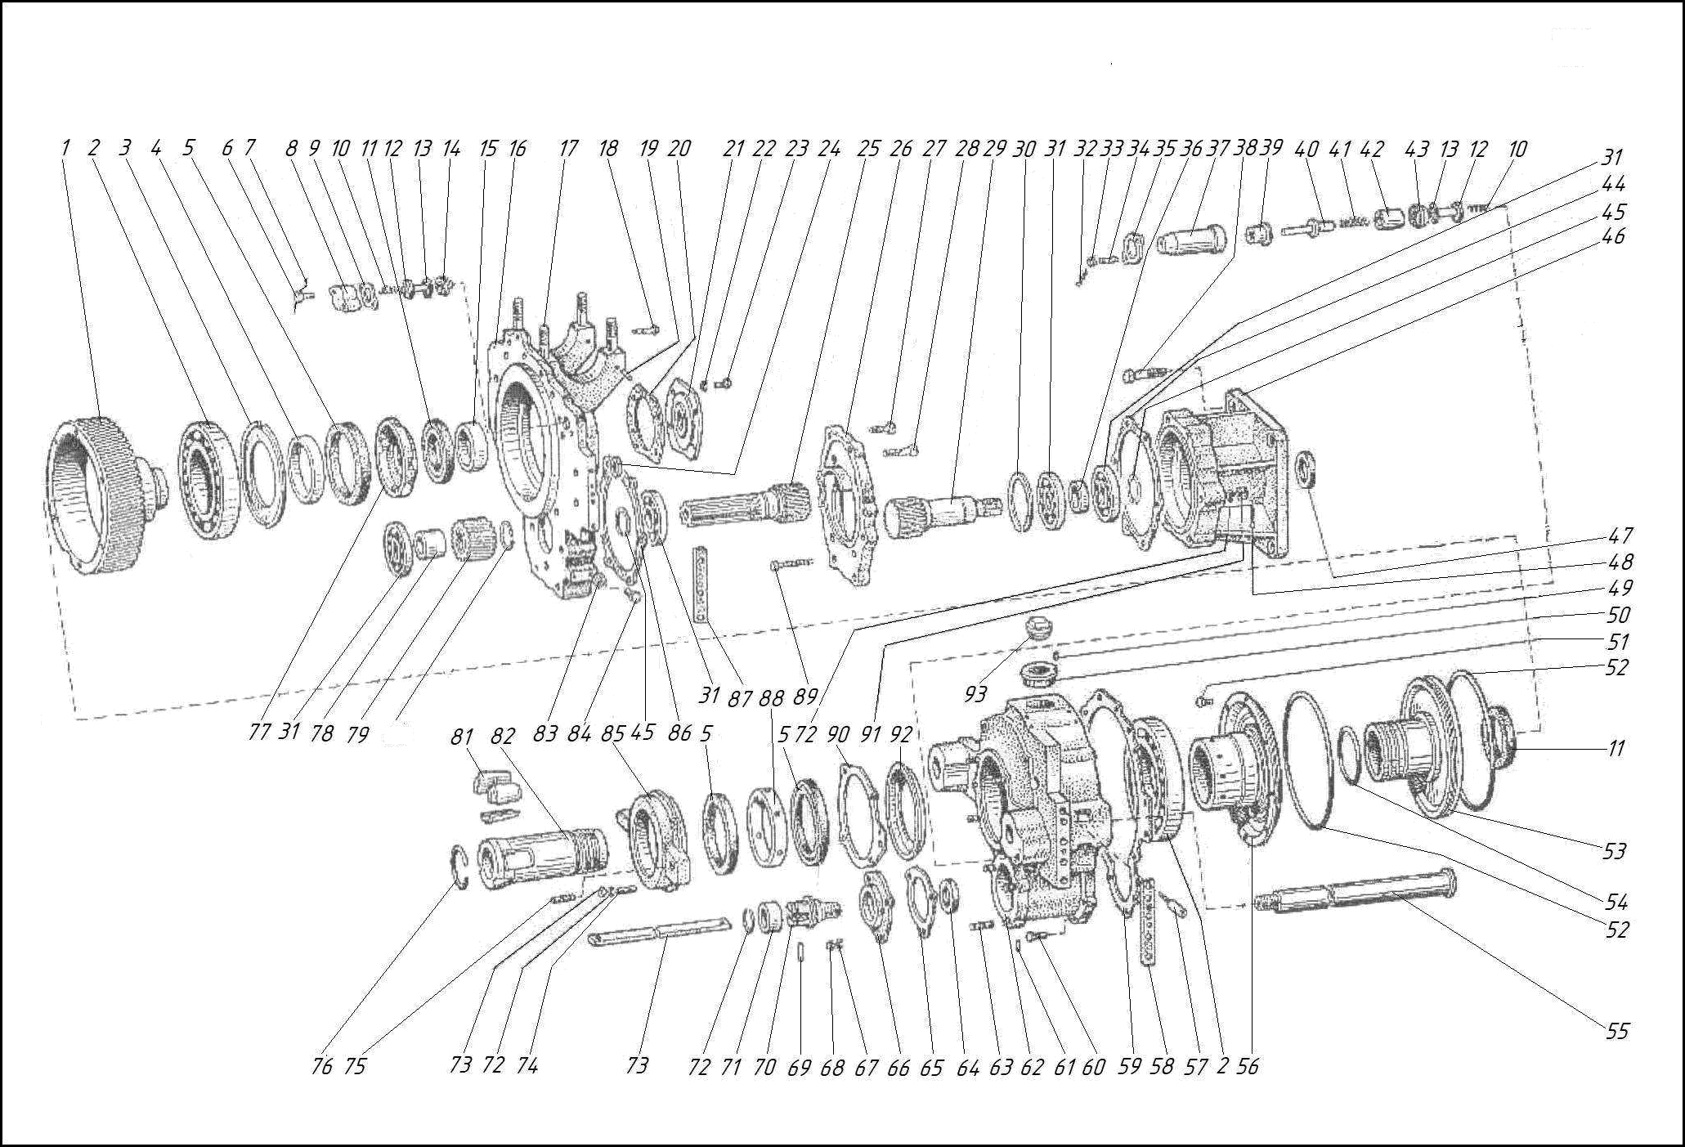
17

17 1 | НKP100MHА-2-2000 | Reduktor sa vazdušnim motorom | Reducer with air motor
 | НKP100MВHА-2-2000*
1 | HKP100M-1-1031 | Zupčanik | Gear wheel
2 | 8338.226 | Ležaj | Bearing
3 | HKP100M-1-2039 | Poklopac | Cover
4 | HKP100M-1-1032 | Čaura | Bushing
5 | 6969.130X160 | Zaptivka čaše | Cup packing
6 | 7796.M10X45 | Zavrtanj | Bolt
7 | 18143.2-Т-12X18H10Т | Žica | Wire
8 | HKP100M-1-2083 | Poklopac | Cover
9 | HKP100M-1-2084 | Zaptivka | Gasket
10 | HKP100M-1-2032 | Opruga | Spring
11 | 6969.90X120 | Zaptivka čaše | Cup packing
12 | HKP100M-1-2400A | Ventil | Valve
13 | 9833.032-040-46-2-2 | Prsten | Ring
14 | HKP100M-1-2034 | Kućište ventila | Valve body
15 | HKP100M-1-1033 | Čaura | Bushing
16 | HKP100MA-1-2500 | Poklopac | Cover
 | HKP100MA-1-2500A | Poklopac | Cover
17 | HKP100MA-1-2025 | Vijak | Stud
18 | 7796.M12X50 | Zavrtanj | Bolt
19 | 3128.8h8X40 | Igl | Pin
20 | HKP100M-1-2018 | Zaptivka | Gasket
21 | HKP100M-1-2001 | Poklopac | Cover
22 | 6402.10 65Г | Podloška | Washer
23 | 7796.M10X25 | Zavrtanj | Bolt
24 | 6969.25X45 | Zaptivka čaše | Cup packing
25 | HKP100MП-1-2041 | Pionir šlem | Pinion slem
26 | HKP100MП-1-2600 | Prirubnica | Flange
27 | 7796.M12X35 | Zavrtanj | Bolt
28 | 7796.M12X50 | Zavrtanj | Bolt
29 | HKP100MП-1-2009 | Pionir šlem | Pinion slem
30 | 13941.1A110 | Prsten | Ring
31 | 8338.310 | Ležaj | Bearing
32 | 397.2,5X25-001 | Rascepka | Colter pin
33 | 5915.M10 | Navrtka | Nut
34 | HKP100M-1-2080 | Vijak | Stud
35 | HKP100M-1-2802 | Prirubnica | Flange
36 | HKP100MП-1-2014 | Čaura | Bushing
37 | HKP100M-1-2801 | Čaša | Cup
38 | 7796.M16X65 | Zavrtanj | Bolt
39 | HKP100M-1-2056 | Čaura | Bushing
40 | HKP100M-1-2027 | Taster | Tappet
41 | HKP100M-1-2054 | Opruga | Spring
42 | HKP100M-1-2053 | Čaura | Sleeve
43 | HKP100M-1-2024 | Kućište ventila | Valve body
44 | HKP100MП-1-2012 | Zaptivka | Gasket
45 | 13940.1A50 | Prsten | Ring
46 | HKP100MП-1-2015 | Među telo | Intermediate bodi
47 | 397.4X36-001 | Rascepka | Colter pin
48 | 6402.16 65Г | Podloška | Washer
49 | 5915.M16 | Navrtka | Nut
50 | HKP100MП-1-8000 | Vazdušni motor | Air motor
51 | HKP100MП-1-2042 | Zaptivka | Gasket
52 | 6969.50X70 | Zaptivka čaše | Cup packing
53 | 397.3X32-001 | Rascepka | Colter pin
54 | 1476.M6X16 | Vijak | Screw
55 | HKP100MA-1-1012 | Čaura | Bushing
56 | 7796.M10X16 | Zavrtanj | Bolt
57 | HKP100M-1-1040 | Prsten | Ring
58 | HKP100M-1-1020 | Klip | Piston
59 | 9833.100-110-58-2-2 | Prsten | Ring
60 | HKP100MA-1-2028 | Vođica | Guide
61 | HKP100M-1-1018 | Poklopac | Cover
62 | HKP100-1-2076 | Vijak | Stud
63 | HKP100-1-2063 | Zaptivka | Gasket
64 | HKP100M-1-2020 | Zaptivka | Gasket
65 | 7796.M12X35 | Zavrtanj | Bolt
66 | 3128.3h8X18 | Igl | Pin
67 | HKP100MA-1-2900 | Kućište | Body
 | HKP100MA-1-2900-01 | Kućište | Body
68 | 22032.M12X25 | Vijak | Stud
69 | 8752.1 50X70-2 | Zaptivka čaše | Cup packing
70 | HKP100M-1-1030 | Zaptivka | Gasket
71 | HKP100M-1-2004A | Poklopac | Cover
72 | 6402.12 65Г | Podloška | Washer
73 | 5915.M12 | Navrtka | Nut
74 | HKP100M-2-2007 | Igl | Pin
75 | HKP100M-2-2005 | Adapter | Adapter
76 | HKP100M-2-2006 | Čaura | Bushing
77 | HKP100M-2-2002 | Opružni prsten | Spring ring
78 | HKP100M-2-2008 | Međuosovina | Intermediate shaft
79 | HKP100M-1-1024 | Vijak | Stud
80 | 22032.M12X45 | Vijak | Stud
81 | HKP100-1-1017 | Distancioni prsten | Spacer ring
82 | HKP100M-1-1036K | Čaura | Bushing
83 | HKP100M-1-2003 | Distanciona čaura | Distance bushing
84 | HKP100M-1-2038 | Zupčanik | Gear
85 | HKP100M-1-2002 | Opružni prsten | Spring ring
86 | HKP100M-1-1038 | Ekscentrik | Cam
87 | HKP100M-1-1021 | Čaura | Sleeve
88 | 16-02-78.14 | Podloška | Washer
89 | 16-01-78.M14X1,5 | Čep | Plug
90 | HKP100M-1-2300A | Poklopac | Cover
91 | HKP100MП-1-2004 | Zaptivka | Gasket
92 | HKP100-1-2068 | Zaptivka | Gasket
93 | HKP100M-1-1034K | Regulacioni prsten | Adjusting ring
94 | 7796.M12X75 | Zavrtanj | Bolt
95 | HKP100M-1-2019 | Zaptivka | Gasket
96 | 5915.M12 | Navrtka | Nut
97 | HKP100M-1-1035 | Poklopac | Cover
98 | HKP100MA-1-1037 | Čep | Plug

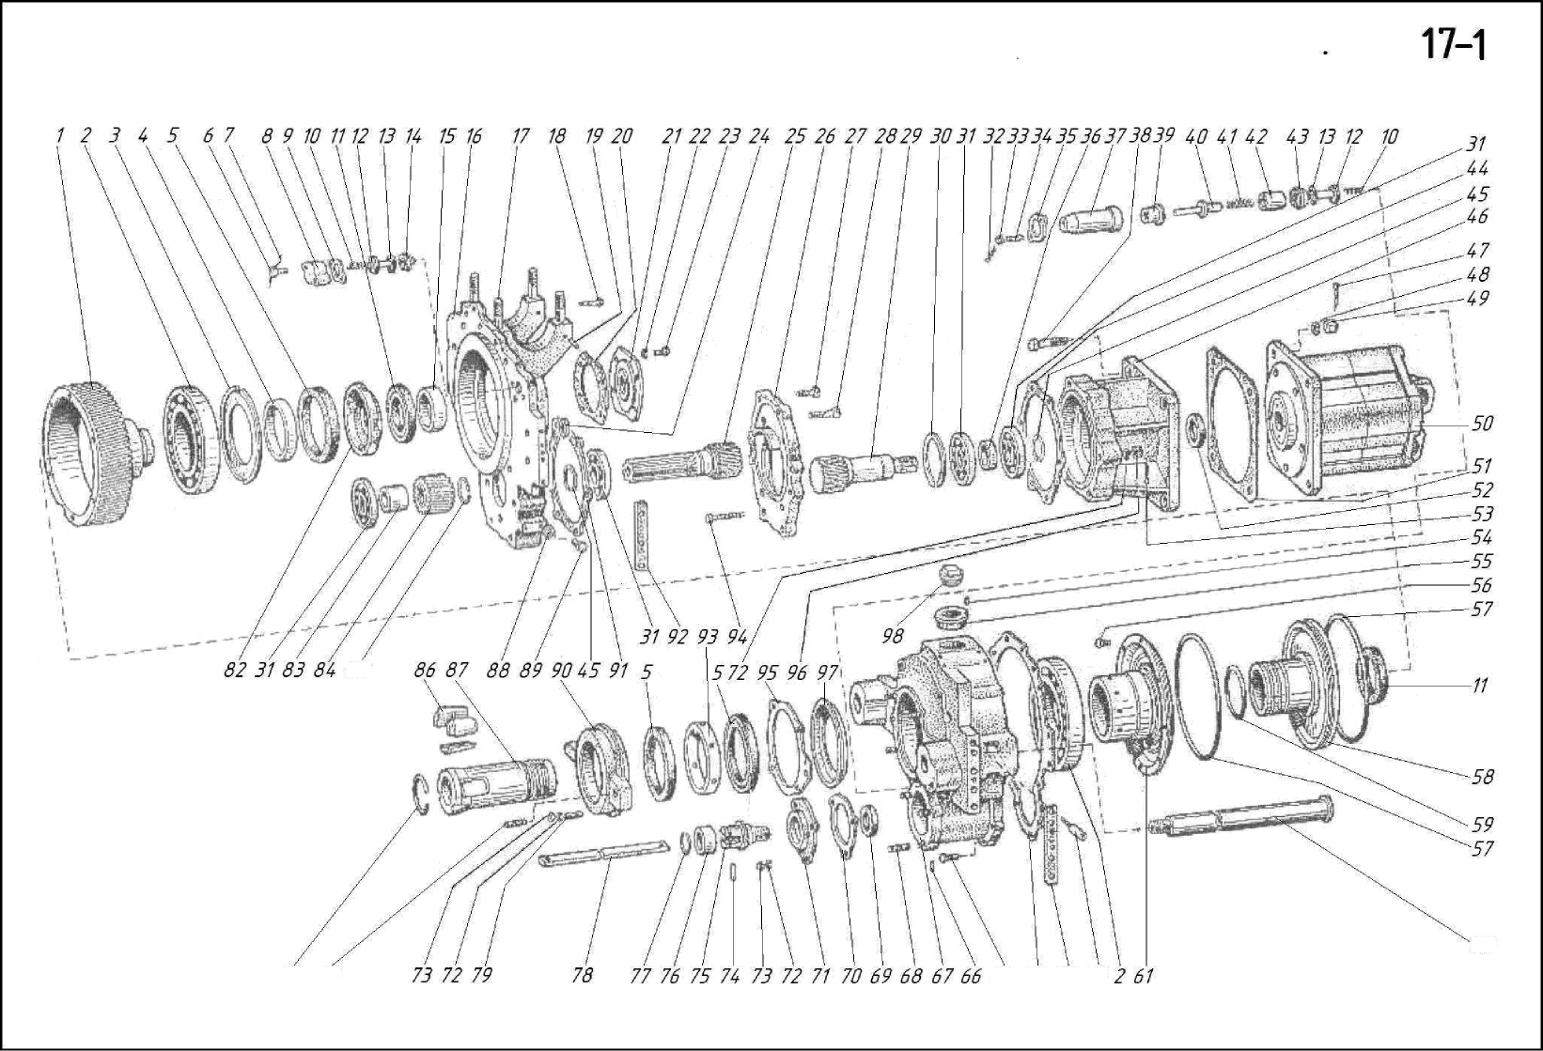

18 | НKP100MА-1-3000 | Kontrolna tabla | Control panel
1 | 7796.M10X90 | Zavrtanj | Bolt
2 | 6402.10 65Г | Podloška | Washer
3 | HKP100-1-3300 | Cilindar | Cylinder
4 | HKP100-1-3047 | Zaptivka | Gasket
5 | HKP100MA-1-3015 | Veza | Tie-rod
6 | HKP100M-1-3005 | Spojnica | Union
7 | 6969.45X65 | Zaptivka čaše | Cup packing
8 | 18143.1,6-Т-12X18H10Т | Žica | Wire
9 | HKP100-1-3034 | Klizni ventil | Slide valve
10 | HKP100-1-3009 | Opruga | Spring
11 | 3722.V19,525 mmP | Kugla | Ball
12 | HKP100-1-3011 | Zaptivka | Gasket
13 | 3128.10h8X22 | Igl | Pin
14 | HKP100-1-3600 | Poklopac | Cover
 | HKP100-1-3100 | Kućište kontrolne table | Control panel case
15 | HKP100-1-3039 | Čaura | Bushing
16 | HKP100-1-3010 | Zaptivka | Gasket
17 | HKP100-1-3200 | Cilindar | Cylinder
18 | HKP100-1-3050 | Klizni ventil | Slide valve
19 | HKP100MA-1-3048 | Nosač | Carrier
20 | 9833.025-031-36-2-2 | Prsten | Ring
21 | HKP100-1-3049 | Poklopac | Cover
22 | HKP100-1-3053 | Ručka startnog ventila | Starting cock handle
23 | ПP22-0036 | Navrtka ručke startnog ventila | Starting cock handle nut
24 | 7796.M10X110 | Zavrtanj | Bolt
25 | 5915.M10 | Navrtka | Nut
26 | HKP100M-1-3006 | Ručni točak | Handwheel
27 | 9833.016-020-25-2-2 | Prsten | Ring
28 | HKP100-1-3001 | Čaura | Sleeve bushing
29 | БA100M-1-16-3 | Zaptivka | Gasket
30 | HKP100M-1-3815 | Vreteno | Stem
31 | HKP100M-1-3051 | Podloška | Washer
32 | HKP100-1-3031 | Zaptivka | Gasket
33 | 11371.6.02.21 | Podloška | Washer
34 | 5915.M6 | Navrtka | Nut
35 | 397.1,6X16-002 | Rascepka | Colter pin
36 | 18143.1,6-Т-12X18H10Т | Žica | Wire
37 | 7796.M10X85 | Zavrtanj | Bolt
38 | HKP100MA-1-3500 | Kućište | Body
39 | HKP100MA-1-3055 | Klizni ventil | Slide valve
40 | HKP100MA-1-9107 | Spojnica | Union
41 | HKP100MA-2-3058 | Spojnica | Union
42 | HKP100MA-1-3060 | T-spoj | T-joint
43 | HKP100M-1-3041 | Klizni ventil | Slide valve
44 | HKP100-1-3004 | Opruga | Spring
45 | HKP100-1-3026 | Zaptivka | Gasket
46 | HKP100-1-3400 | Nosač | Carrier
47 | HKP100MA-1-3048 | Nosač | Carrier
48 | HKP100M-1-3054 | Zaptivka | Gasket
49 | HKP100MA-1-3056 | Poklopac | Cover
50 | 7796.M10X25 | Zavrtanj | Bolt
51 | БA100M-1-16-29 | Zatezna opruga | Retainer spring
52 | HKP100M-1-3057 | Ručka | Handie
53 | БA100M-1-16-18 | Regulaciona opruga | Regulator spring
54 | HKP100M-1-3002 | Vreteno | Stem
55 | БA100K-1-26-43 | Ručka | Handie
56 | 5915.M16X1,5 | Navrtka | Nut
57 | HKP100-1-3045 | Ventil | Valve
58 | 7796.M8X55 | Zavrtanj | Bolt
59 | HKP100-1-3700 | Poklopac | Cover
60 | HKP100-1-3016 | Zaptivka | Gasket
61 | HKP100-1-3019 | Klizni ventil | Slide valve

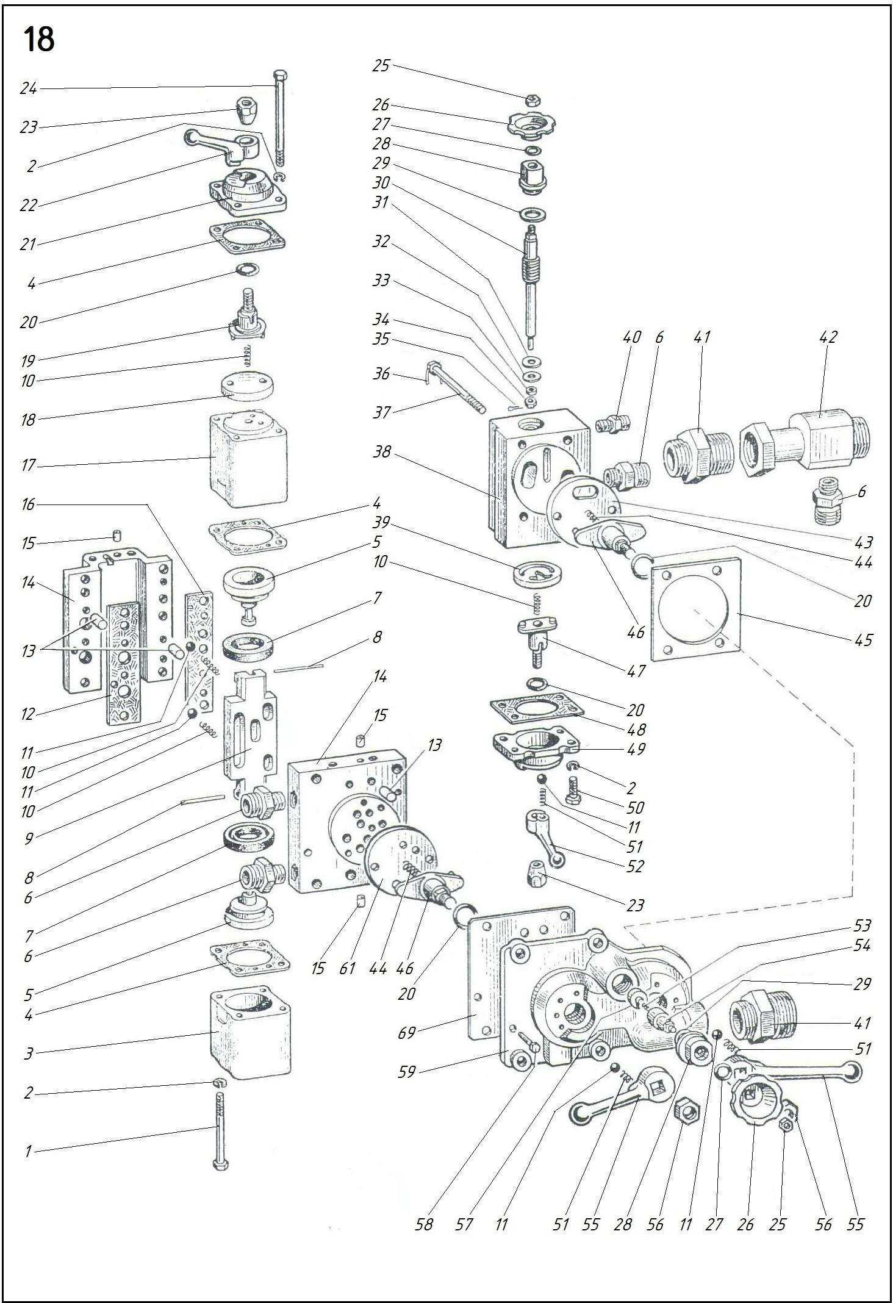

19 | НKP100MHА-1-3000 | Kontrolna tabla | Control panel
1 | 7796.M10X85 | Zavrtanj | Bolt
2 | 18143.1,6-Т-12X18H10Т | Žica | Wire
3 | 7796.M10X90 | Zavrtanj | Bolt
4 | 6402.10 65Г | Podloška | Washer
5 | HKP100-1-3300 | Cilindar | Cylinder
6 | HKP100-1-3047 | Zaptivka | Gasket
7 | HKP100-1-3015 | Veza | Tie-rod
8 | HKP100M-1-3005 | Spojnica | Union
9 | HKP100-1-3100 | Kućište | Body
 | HKP100-1-3600 | Poklopac | Cover
10 | 6969.45X65 | Zaptivka čaše | Cup packing
11 | 18143.1,6-Т-12X18H10Т | Žica | Wire
12 | HKP100-1-3034 | Klizni ventil | Slide valve
13 | HKP100-1-3009 | Opruga | Spring
14 | 3722.V19,525 mmP | Kugla | Ball
15 | HKP100-1-3011 | Zaptivka | Gasket
16 | 3128.10h8X22 | Igl | Pin
17 | HKP100-1-3039 | Čaura | Bushing
18 | HKP100-1-3010 | Zaptivka | Gasket
19 | HKP100-1-3200 | Cilindar | Cylinder
20 | HKP100-1-3050 | Klizni ventil | Slide valve
21 | HKP100MA-1-3048 | Nosač | Carrier
22 | 9833.025-031-36-2-2 | Prsten | Ring
23 | HKP100-1-3049 | Poklopac | Cover
24 | HKP100-1-3053 | Ručka startnog ventila | Starting cock handle
25 | ПP22-0036 | Navrtka ručke startnog ventila | Starting cock handle nut
26 | 7796.M10X110 | Zavrtanj | Bolt
27 | HKP100M-1-3057 | Ručka | Handle
28 | 7796.M10X25 | Zavrtanj | Bolt
29 | БA100M-1-16-29 | Zatezna opruga | Retainer spring
30 | HKP100MПA-1-3002 | Poklopac | Cover
31 | HKP100M-1-3054 | Zaptivka | Gasket
32 | HKP100MПA-1-3001 | Klizni ventil | Slide valve
33 | HKP100MПA-1-3014 | Kućište | Body
34 | HKP100MA-1-9107 | Spojnica | Union
35 | HKP100MA-2-3058 | Spojnica | Union
36 | HKP100MПA-1-3009 | Motorni klizni ventil | Motor slide valve
37 | HKP100-1-3004 | Opruga | Spring
38 | HKP100-1-3400 | Nosač | Carrier
39 | HKP100-1-3026 | Zaptivka | Gasket
40 | HKP100-1-3045 | Ventil | Valve
41 | БA100M-1-16-8 | Regulaciona opruga | Regulator spring
42 | HKP100M-1-3002 | Vreteno | Stem
43 | БA100M-1-16-3 | Zaptivka | Gasket
44 | БA100K-1-26-43 | Ručka | Handle
45 | 5915.M16X1,5. | Navrtka | Nut
46 | 5915.M10 | Navrtka | Nut
47 | HKP100M-1-3006 | Ručni točak | Handwheel
48 | 9833016-020-25-2-2 | Prsten | Ring
49 | HKP100-1-3001 | Čaura | Sleeve bushing
50 | 7796.M8X55 | Zavrtanj | Bolt
51 | 9833.035-040-30-2-2 | Prsten | Ring
52 | 5915.M12 | Navrtka | Nut
53 | 6402.12 65Г | Podloška | Washer
54 | 14896.38X28-6 | Zaptivka čaše | Cup packing
55 | 532.04.07.116 | Klip | Piston
56 | 9833.014-018-25-2-2 | Prsten | Ring
57 | HKP100MПA-1-3015 | Kućište ventila | Valve body
58 | HKP100MП-1-3025 | Poklopac | Cover
59 | 9833.045-050-30-2-2 | Prsten | Ring
60 | 532.04.07.140 | Opruga | Spring
61 | 532.04.07.141 | Čaura | Bushing
62 | 532.04.07.018 | Poklopac | Cover
63 | 7796.M10X30 | Zavrtanj | Bolt
64 | 9649.12.02.029 | Podloška | Washer
65 | 397.3,2X25-002 | Rascepka | Colter pin
66 | HKP100MПA-1-3040 | Ručka | Handle
67 | 532.04.07.139 | Osovina | Axle
68 | 532.04.07.142 | Podloška | Washer
69 | 532.04.07.144 | Veza | Tie-rod
70 | 532.04.07.143 | Čaura | Bushing
71 | 532.04.07.138 | Ram | Frame
72 | 532.04.07.137 | Zaptivka | Seal
73 | 532.04.07.134 | Podloška | Washer
74 | 532.04.07.135 | Čaura | Bushing
75 | 33.033.497 | Adapter za krajnje sedište | End-seating adapter
76 | HKP100MПA-1-3008 | Traka | Strip
77 | 532.04.07.145 | Poklopac | Cover
78 | HKP100MA-1-3700 | Poklopac kontrolne table | Control panel cover
79 | HKP100-1-3016 | Zaptivka | Gasket
80 | HKP100-1-3019 | Klizni ventil | Slide valve

20 | НKP100MА-1-4000 | Dozator | Feeder
1 | HKP100MA-1-4018 | Ključ | Key
2 | 6969.75X95 | Zaptivka čaše | Cup packing
3 | HKP100MA-1-4200 | Klip | Piston
4 | HKP100-1-4011 | Poluprsten | Half-ring
5 | HKP100M-1-4100 | Cilindar | Cylinder
6 | HKP100M-1-4001 | Zaptivka | Gasket
7 | HKP100M-1-4003 | Poklopac | Cover
8 | 7796.M12X30 | Zavrtanj | Bolt
9 | 18143.1,6Т-12X18H10Т | Žica | Wire
10 | 31286h9X50 | Igl | Pin

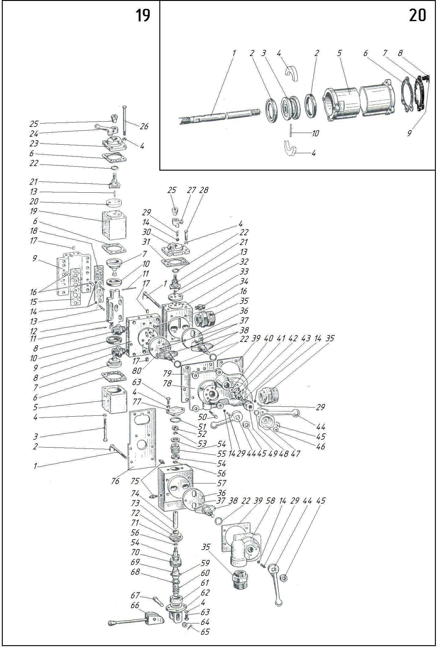

21 | НKP100MА-2-5000 | Rasporna kolona | Jack column
 | НKP100MА-2-5000-01*
1 | 7796.M24X90 | Zavrtanj | Bolt
2 | HKP100MA-1-5020 | Crevo | Hose
 | HKP100MA-1-5011 | Ogrlica | Collar
3 | HKP100MA-2-5040 | Cev | Pipe
 | HKP100MA-2-5040-01* | Cev | Pipe
4 | БA100K-2-0-14 | Osovina | Axle
5 | 11371.12.02.21 | Podloška | Washer
6 | 397.3X20-001 | Rascepka | Colter pin
7 | БA100M-2-5-0 | Kućište valjka | Roller cage
8 | БA100K-2-0-8 | Valjak | Roller
9 | 9650.22X50 | Osovina | Axle
10 | 397.4X28-001 | Rascepka | Colter pin
11 | 11371.20.02.21 | Podloška | Washer
12 | БA100K-2-4-0 | Navrtka | Cap nut
13 | БA100K-2-19-0 | Ručno vitlo | Hand winch
14 | БA100K-2-0-16 | Zatezna podloška | Lock washer
15 | 7796.M12X35 | Zavrtanj | Bolt
16 | HKP100MA-1-5012 | Osovina | Axle
17 | БA100M-2-2-0 | Vijak | Screw
18 | БA100M-2-3-3 | Poluprsten | Half-ring

22 | НKP100MНА-1-6000 | Prigušivač | Mufler
1 | HKP100MПA-1-6003 | Kućište | Body
2 | HKP100MПA-1-6004 | Prirubnica | Flauge
3 | HKP100MП-1-6006 | Prsten | Ring
4 | HKP100MП-1-6007 | Prsten | Ring
5 | HKP100MП-1-6008 | Membrana | Diaphragm
6 | HKP100MП-1-6009 | Prsten | Ring
7 | 13941.1A110 | Prsten | Ring

23 | НKP100M-2-8000 | Samopodmazujući filter-podmazivač | Self-actingfilter-lubricator
1 | 7796.M12X150 | Zavrtanj | Bolt
2 | HKP100M-0-8007 | Prirubnica | Flauge
3 | 9833.120-130-58-2-2 | Prsten | Ring
4 | HKP100M-0-8100 | Klip za punjenje | Filler clip
5 | HKP100M-0-8004 | Kućište filtera | Filter body
6 | HKP100M-0-8200 | Kućište podmazivača | Lubricator body
7 | ПA23-26 | Čep podmazivača | Lubricator plug
8 | 5915.M12 | Navrtka | Nut
9 | 6402.12 65Г | Podloška | Washer

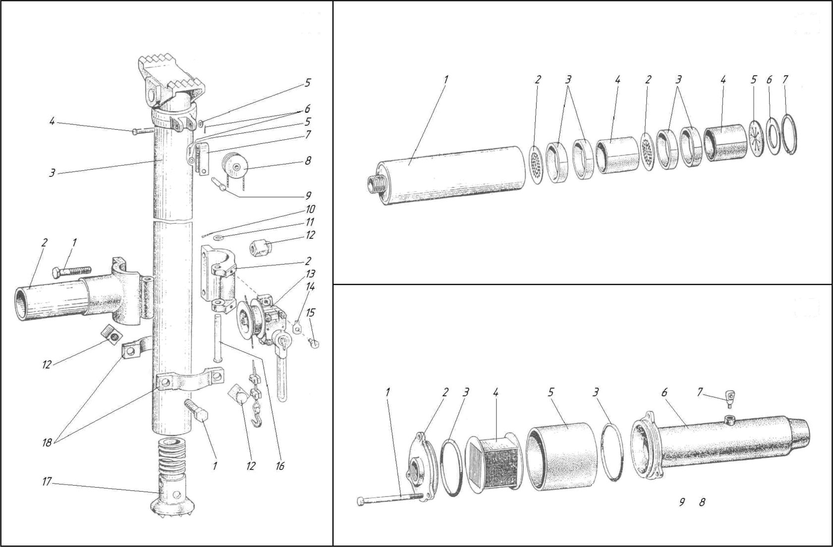

24 | НKP100MА-1-9000 | Uklanjač mulja | Sludge remover
1 | 5398.Б-1-100-5 | Crevo | Hose
2 | 7796.M10X50 | Zavrtanj | Bolt
3 | HKP100MA-1-9200 | Klip | Clip
4 | 6402.10 65Г. | Podloška | Washer
5 | 5915.M10 | Navrtka | Nut
6 | HKP100MA-1-9700 | Izbacivač | Ejector
7 | HKP100MA-1-9011 | Vrha | Tip
8 | HKP100MA-1-9500 | Umetak | Insert
9 | HKP100MA-1-9014 | Navrtka | Nut
10 | 7796.M10X30 | Zavrtanj | Bolt
11 | 5398Б-1-100-5 | Crevo | Hose
12 | 7796.M10X65 | Zavrtanj | Bolt
13 | HKP100MA-1-9003 | Fleksibilni konus | Elexible cone
14 | HKP100MA-1-9800 | Klip | Clip
15 | HKP100MA-1-9300 | Ulazni konus | Inlet cone
16 | HKP100MA-1-9600 | Navrtka | Nut
17 | HKP100MA-1-9403 | Prirubnica | Flauge
18 | HKP100MA-1-9006 | Čaura | Bushing
19 | HKP100MA-1-9400 | Prijemnik mulja | Sludge receiver
20 | HKP100MA-1-9107 | Spojnica | Union
21 | HKP100M-0-9003 | Podloška | Washer
22 | HKP100M-0-9004 | Zaptivka | Sealing
23 | 9833.095-100-30-2-2 | Prsten | Ring
24 | HKP100MA-1-9001 | Poklopac | Cover

25 | НKP100MА-1-9100 | Vazdušni cilindar | Air cylinder
1 | HKP100MA-1-9107 | Spojnica | Union
2 | HKP100MA-1-9110 | Kućište | Body
3 | УПБ1.01.01.002 | Zaptivka čaše | Cup packing
4 | HKP100MA-1-9120 | Ključ | Key
5 | 9833.090-100-58-2-2 | Prsten | Ring
6 | 6969.40X60 | Zaptivka čaše | Cup packing
7 | HKP100MA-1-9101 | Čaura | Bushing
8 | HKP100MA-1-9102 | Zatezna podloška | Spring ring
9 | HKP100MA-1-9106 | Uklanjač prljavštine | Dirt remover
10 | HKP100MA-1-9105 | Konus | Cone
11 | HKP100MA-1-9103 | Zaptivka | Gasket
12 | HKP100MA-1-9104 | Prirubnica | Flange
13 | 6402.8 65Г | Podloška | Washer
14 | 7796.M8X30 | Zavrtanj | Bolt

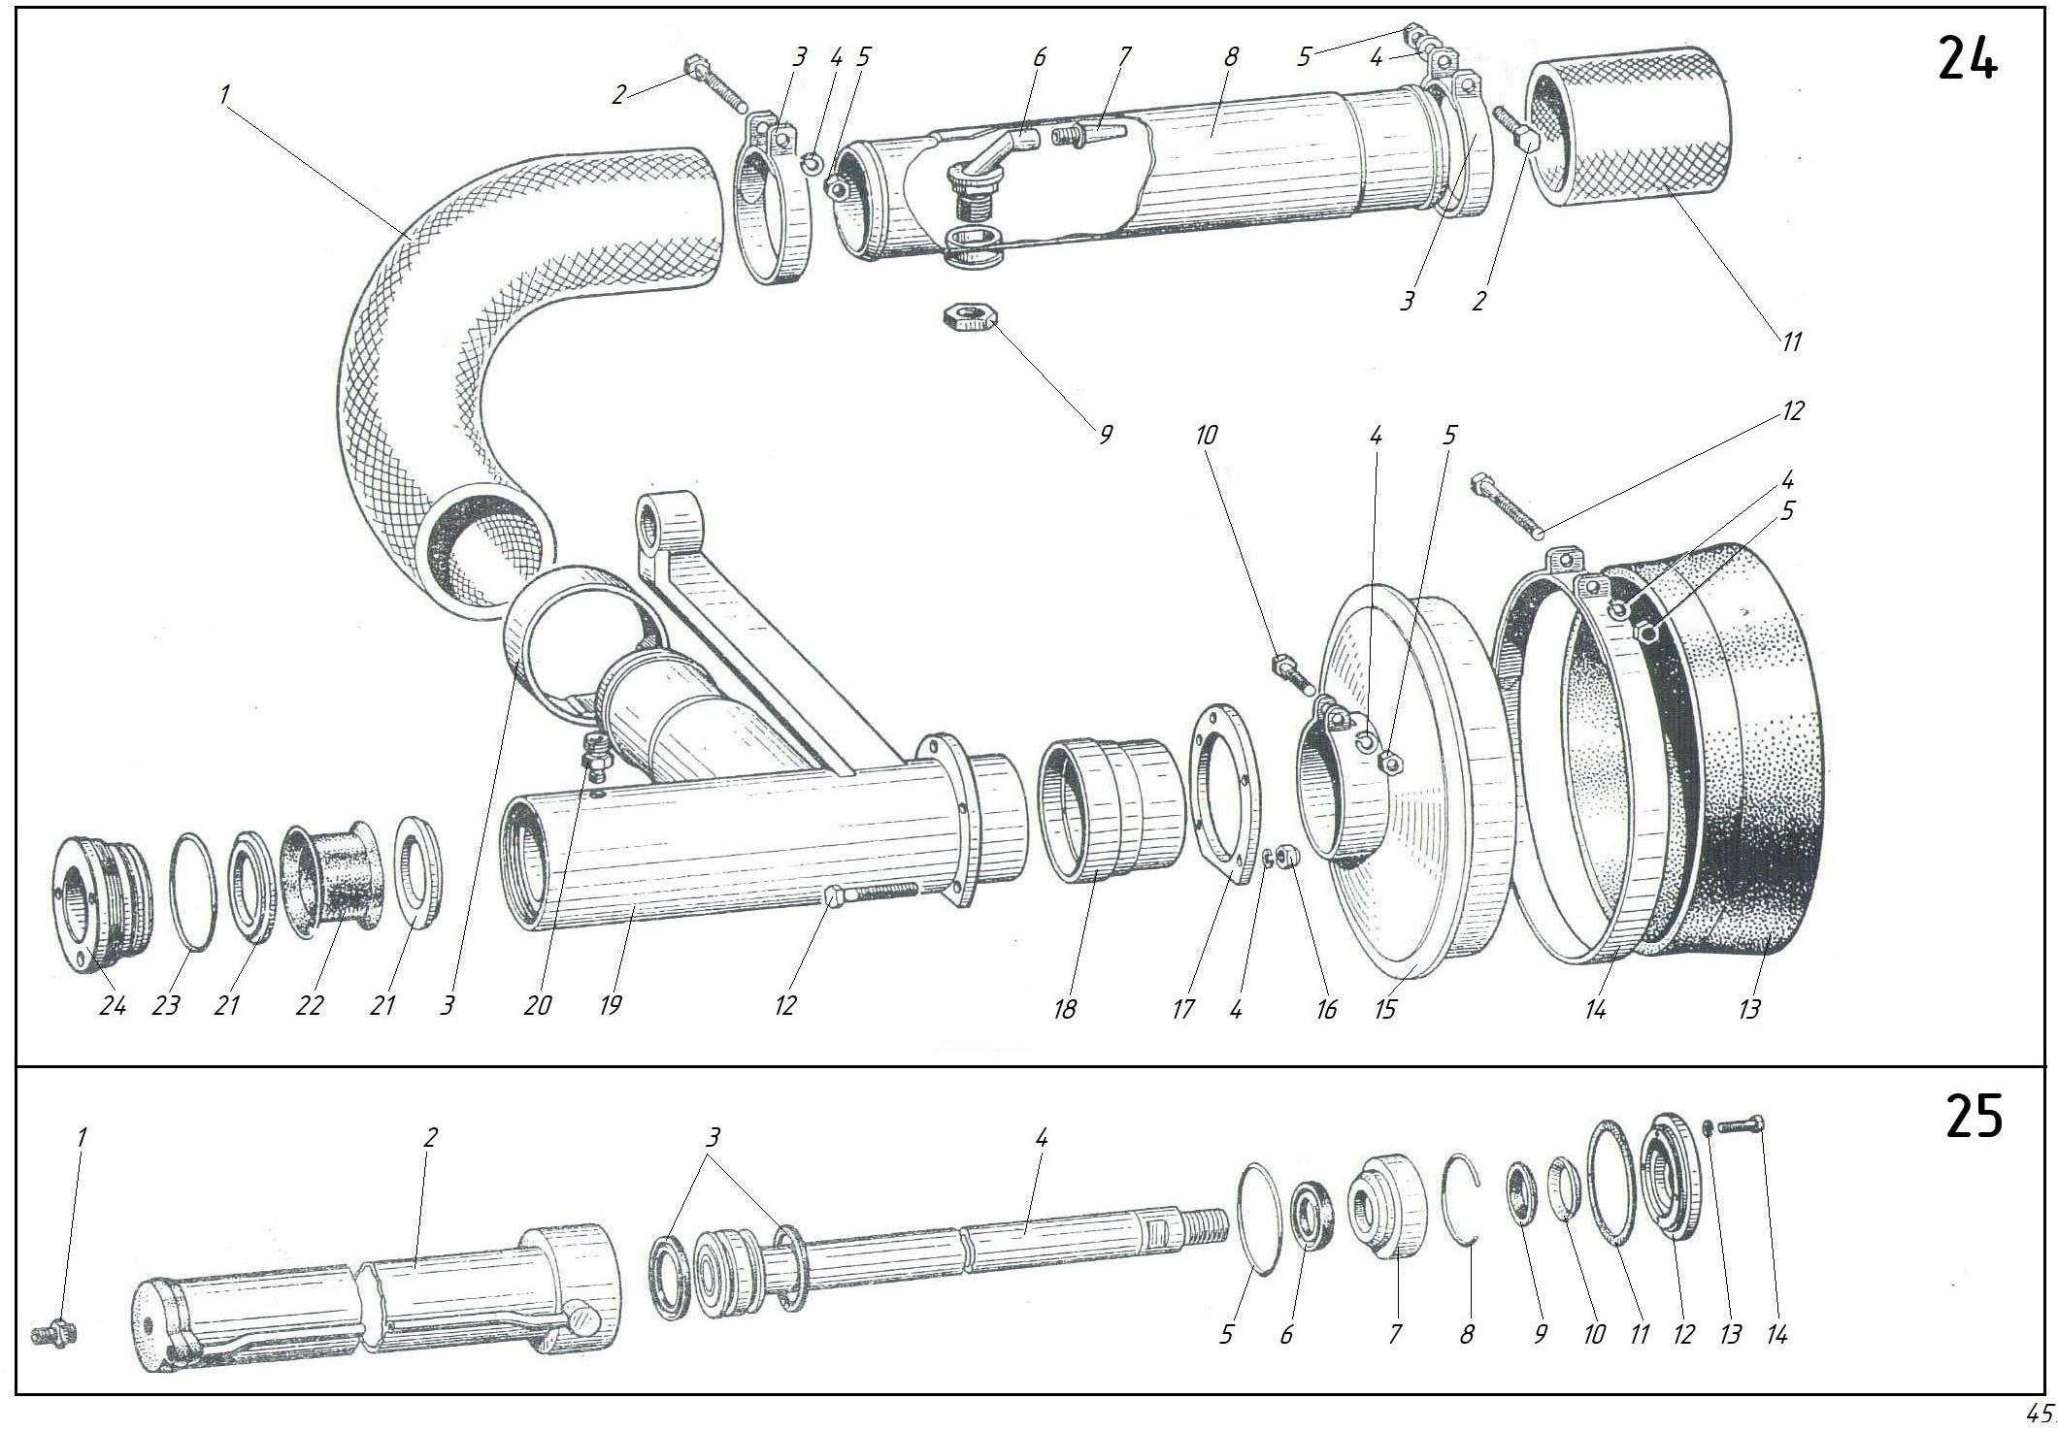
26 | БА100K-2-19-0 | Ručno vitlo | Hand winch
1 | 5915.M12 | Navrtka | Nut
2 | 11371.12.02.21 | Podloška | Washer
3 | БA100M-2-6-0 | Bubanj | Dpum
4 | 8789.Б6X6X18 | Ključ | Key
5 | БA100K-2-9-37 | Kućište reduktora | Reduker body
 | БA100K-2-9-38 | Poklopac reduktora | Reduker cover
6 | БA100M-2-6-8 | Osovina | Shaft
7 | 3128.8h8X20 | Igl | Pin
8 | БA100K-2-19-2 | Pu | Worm
9 | HKP100M-1-1300 | Račna ključ | Ratchet wrench
10 | 7796.M10X50 | Zavrtanj | Bolt
11 | 18143.1,5-Т-12X18H10Т | Žica | Wire
12 | БA100K-2-19-1 | Hvataljka | Catch
13 | 397.3,2X32-001 | Rascepka | Colter pin
14 | 18143.1,5-Т-12X18H10Т | Žica | Wire
15 | 7796.M8X45 | Zavrtanj | Bolt
16 | БA100K-2-9-41 | Stezaljka | Clamp
17 | 3077. 6,4-Г-1-H-180 | Konop | Rope
18 | БA100M-2-6-16 | Kuka | Hook
19 | 5915.M8.8 | Navrtka | Nut
20 | 7796.M6X30 | Zavrtanj | Bolt
21 | 11371.5.02.21 | Podloška | Washer

27 |  | Aksesoari i alatni set | Accessory and tool kit
1 | 2839.7811 36-41 | Ključ | Wrench
2 | 2839.7811 32-36 | Ključ | Wrench
3 | 2839.7811 27-30 | Ključ | Wrench
4 | 2839.7811 24-27 | Ključ | Wrench
5 | 2839.7811 22-24 | Ključ | Wrench
6 | 2839.7811 19-22 | Ključ | Wrench
7 | 2839.7811 17-19 | Ključ | Wrench
8 | 2839.7811 14-17 | Ključ | Wrench
9 | 2839.7811 12-14 | Ključ | Wrench
10 | 17199.7810 | Odvrtač | Serewdriver
11 | HKP100M-1-0500 | Specijalni ključ | Special wrench
12 | HKP100MA-1-5001 | Račni štap | Ratcher bar
13 | HKP100MA-0-1020 | Separator gasa i tečnosti | Gas-and-fluid separator
14 | HKP100M-0-1002 | Šipka | Rod
15 | БA100M-9-3-4 | Merač za bušilice | Bit measuring gauge
16 | HKP100MA-0-1012 | Konusna slavina | Tapered tap
17 | HKP100MA-0-1013 | Zvono | Bell
18 | HKP100-0-1100 | Hvatač za tvrdu leguru | Hard-alloy catcher
19 | K100В | Bušilica | Drill bit
20 | K130 | Bušilica | Drill bit
21 | HKP100MA-2-5040-02 | Cev | Pipe
22 | HKP100MA-0-0050 | Kasi | Casi

*Za HKP100MA,HKP100MПA **Za HKP100MВA,HKP100MВПA
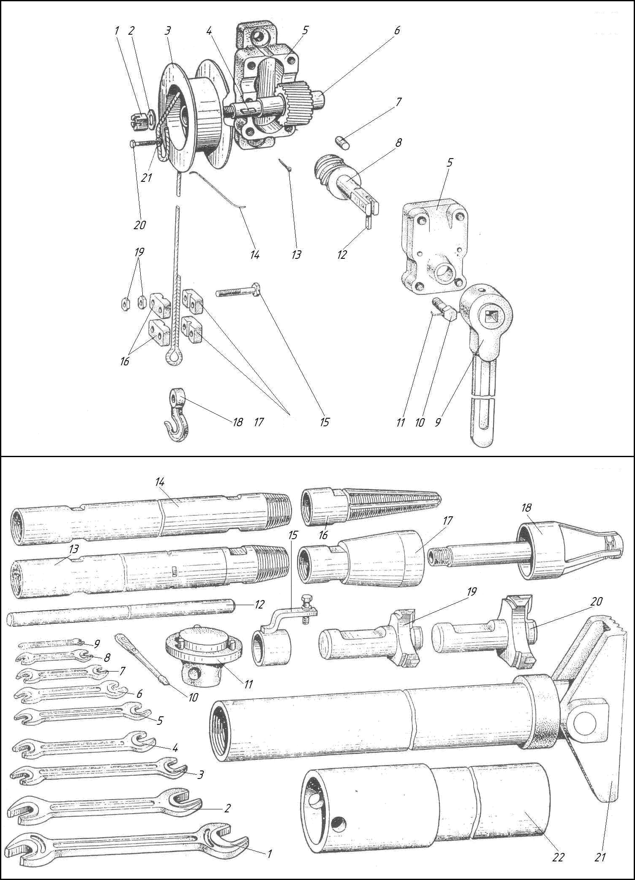
For For

Kоmprativna tabela primene

SUMMARY TABLE OF APPLICABILITY
Naziv  Designation | Količina za izvršenje  Quantity per versi on |  |  |  | Gde ulazi Where included | Naziv  Designation | Količina za izvršenje  Quantity per versi on |  |  |  | Gde ulazi Where included
Naziv  Designation | HKP100MA | HKP100MΠА | HКP100MВА | HКP100MВΠА | Gde ulazi Where included | Naziv  Designation | HKP100MA | HKP100MΠА | HКP100MВА | HКP100MВΠА | Gde ulazi Where included
1 | 2 | 3 | 4 | 5 | 6 | 1 | 2 | 3 | 4 | 5 | 6
HKP100MA-0-0001  HKP100MA-0-0010 | 1  1  1  1  1  1  1  1  3  1  1  1  1  1  1  1  2  1  1 | 2  1 |  | 2  1 | HKP100MПA-0-0000  HKP100MBПA-0-0000  HKP100MПA-0-0000 HKP100MBПA-0-0000 | HKP100MA-0-5100-  02 | 1 | 1 | 1 | 1 | HKP100MA-0-0000  HKP100MПA-0-0000  HKP100MBA-0-0000 HKP100MBПA-0-0000
HKP100MA-0-0300 | 1  1  1  1  1  1  1  1  3  1  1  1  1  1  1  1  2  1  1 |  | 1 |  | HKP100MA-1-0000 HKP100MBA-1-0000 | HKP100MA-0-5100- 03 | 1 | 1 |  |  | HKP100MA-0-0000 HKP100MПA-0-0000
HKP100MA-0-0602 | 1  1  1  1  1  1  1  1  3  1  1  1  1  1  1  1  2  1  1 | 1 | 1 |  | HKP100MA-1-0000  HKP100MПA-1-0000 HKP100MBA-1-0000 | HKP100MA-0-5100- |  | 1 | 1 | 1 | HKP100MBA-0-0000  HKP100MBПA-0-0000 HKP100MПA-0-0000
 | 1  1  1  1  1  1  1  1  3  1  1  1  1  1  1  1  2  1  1 |  |  | 1 | HKP100MBПA-1-0000 | 08 |  |  |  | 1 | HKP100MBПA-0-0000
HKP100MA-0-0603 | 1  1  1  1  1  1  1  1  3  1  1  1  1  1  1  1  2  1  1 | 1 | 1 |  | HKP100MA-1-0000 HKP100MПA-1-0000  HKP100MBA-1-0000 | HKP100MA-0-5101- 02 | 1 | 2 | 1 |  | HKP100MA-0-0000 HKP100MПA-0-0000  HKP100MBA-0-0000
 | 1  1  1  1  1  1  1  1  3  1  1  1  1  1  1  1  2  1  1 |  |  | 1 | HKP100MBПA-1-0000 |  |  |  |  | 2 | HKP100MBПA-0-0000
HKP100MA-0-0604 | 1  1  1  1  1  1  1  1  3  1  1  1  1  1  1  1  2  1  1 | 1 | 1 |  | HKP100MA-1-0000  HKP100MПA-1-0000 HKP100MBA-1-0000 | HKP100MA-0-9700 | 3 | 3 | 3 |  | HKP100MA-0-0000  HKP100MПA-0-0000 HKP100MBA-0-0000
HKP100MA-0-0900 | 1  1  1  1  1  1  1  1  3  1  1  1  1  1  1  1  2  1  1 |  |  | 1 | HKP100MBПA-1-0000  HKP100MA-1-0000 | HKP100MA-1-0000 | 1 |  |  | 3 | HKP100MBПA-0-0000  HKP100MA-0-0000
 | 1  1  1  1  1  1  1  1  3  1  1  1  1  1  1  1  2  1  1 |  | 1 |  | HKP100MBA-1-0000 | HKP100MA-1-0030 | 2 |  |  |  | HKP100MA-1-0000
HKP100MA-0-1000 | 1  1  1  1  1  1  1  1  3  1  1  1  1  1  1  1  2  1  1 | 1 | 1 |  | HKP100MA-0-0000 HKP100MПA-0-0000  HKP100MBA-0-0000 |  |  | 2 | 2 | 2 | HKP100MПA-1-0000 HKP100MBA-1-0000  HKP100MBПA-1-0000
 | 1  1  1  1  1  1  1  1  3  1  1  1  1  1  1  1  2  1  1 |  |  | 1 | HKP100MBПA-0-0000 | HKP100MA-1-0401 | 1 |  |  |  | HKP100MA-1-0000
HKP100MA-0-1012*  HKP100MA-0-1013* | 1  1  1  1  1  1  1  1  3  1  1  1  1  1  1  1  2  1  1 | 1  1 | 1  1 | 1  1 |  | HKP100MA-1-0402 | 1 |  | 1 |  | HKP100MBA-1-0000  HKP100MA-1-0000
HKP100MA-0-1020* | 1  1  1  1  1  1  1  1  3  1  1  1  1  1  1  1  2  1  1 | 3 | 3 | 3 |  |  |  |  | 1 |  | HKP100MBA-1-0000
HKP100MA-0-1021 | 1  1  1  1  1  1  1  1  3  1  1  1  1  1  1  1  2  1  1 | 1 | 1 | 1 | HKP100MA-0-1020 | HKP100MA-1-0403 | 1 |  |  |  | HKP100MA-1-0000
HKP100MA-0-1022 | 1  1  1  1  1  1  1  1  3  1  1  1  1  1  1  1  2  1  1 | 1 | 1 | 1 | HKP100MA-0-1020 |  |  |  | 1 |  | HKP100MBA-1-0000
HKP100MA-0-1023  HKP100MA-0-1030 | 1  1  1  1  1  1  1  1  3  1  1  1  1  1  1  1  2  1  1 | 1  1 | 1  1 | 1  1 | HKP100MA-0-1020  HKP100MA-0-1020 | HKP100MA-1-0404 | 2 |  | 2 |  | HKP100MA-1-0000  HKP100MBA-1-0000
HKP100MA-0-2200 | 1  1  1  1  1  1  1  1  3  1  1  1  1  1  1  1  2  1  1 | 1 | 1 | 1 | HKP100MA-0-3000 | HKP100MA-1-0700 | 1 |  |  |  | HKP100MA-1-0000
HKP100MA-0-3000 | 1  1  1  1  1  1  1  1  3  1  1  1  1  1  1  1  2  1  1 | 1 | 1 |  | HKP100MA-0-0000 HKP100MПA-0-0000  HKP100MBA-0-0000 |  |  | 1 | 1 | 1 | HKP100MПA-1-0000 HKP100MBA-1-0000  HKP100MBПA-1-0000
 | 1  1  1  1  1  1  1  1  3  1  1  1  1  1  1  1  2  1  1 |  |  | 1 | HKP100MBПA-0-0000 | HKP100MA-1-0701 | 2 | 2 | 2 | 2 | HKP100MA-1-0700
HKP100MA-0-3100  HKP100MA-0- | 1  1  1  1  1  1  1  1  3  1  1  1  1  1  1  1  2  1  1 | 1 | 1 | 1 | HKP100MA-0-3000  HKP100MA-0-0000 | HKP100MA-1-0702  HKP100MA-1-0703 | 1  1 | 1  1 | 1  1 | 1  1 | HKP100MA-1-0700  HKP100MA-1-0700
4000A | 1  1  1  1  1  1  1  1  3  1  1  1  1  1  1  1  2  1  1 | 3 | 2 |  | HKP100MПA-0-0000 HKP100MBA-0-0000 | HKP100MA-1-0704 HKP100MA-1-0705 | 2  2 | 2  2 | 2  2 | 2  2 | HKP100MA-1-0700 HKP100MA-1-0700
 | 1  1  1  1  1  1  1  1  3  1  1  1  1  1  1  1  2  1  1 |  |  | 3 | HKP100MBПA-0-0000 | HKP100MA-1-0706 | 2 | 2 | 2 | 2 | HKP100MA-1-0700
HKP100MA-0-5100 | 1  1  1  1  1  1  1  1  3  1  1  1  1  1  1  1  2  1  1 | 1 | 1 |  | HKP100MA-1-0000  HKP100MПA-1-0000 HKP100MBA-1-0000 | HKP100MA-1-0707  HKP100MA-1-0710 HKP100MA-1-0720 | 2  1  1 | 2  1  1 | 2  1  1 | 2  1  1 | HKP100MA-1-0700  HKP100MA-1-0700 HKP100MA-1-0700
HKP100MA-0-5100- | 1  1  1  1  1  1  1  1  3  1  1  1  1  1  1  1  2  1  1 |  |  | 1 | HKP100MBПA-1-0000  HKP100MA-1-0000 | HKP100MA-1-0800 | 1 |  | 1 |  | HKP100MA-1-0000  HKP100MBA-1-0000
01 | 1  1  1  1  1  1  1  1  3  1  1  1  1  1  1  1  2  1  1 | 1 | 1 | 1 | HKP100MПA-1-0000 HKP100MBA-1-0000 HKP100MBПA-1-0000 | HKP100MA-1-0804 HKP100MA-1-0805 | 4  1 |  | 4  1 |  | HKP100MA-1-0800 HKP100MA-1-0800
* Ulazi u komplet alata I pribora
To be included into a set of tools and accessorios

1 | 2 | 3 | 4 | 5 | 6 | 1 | 2 | 3 | 4 | 5 | 6
HKP100MA-1-0820 HKP100MA-1-1000  HKP100MA-1-1000-01 HKP100MA-1-1-1012  HKP100MA-1-1-1016 HKP100MA-1-1-1037  HKP100MA-1-1-1067  HKP100MA-1-2000 HKP100MA-1-2000-01 HKP100MA-1-2025  HKP100MA-1-2025  HKP100MA-1-2500 HKP100MA-1-2500A HKP100MA-1-2700 HKP100MA-1-2900 HKP100MA-1-2900-01 HKP100MA-1-3000  HKP100MA-1-3048  HKP100MA-1-3055 HKP100MA-1-3056 HKP100MA-1-3058  HKP100MA-1-3060 HKP100MA-1-3500 HKP100MA-1-4000  HKP100MA-1-4018 HKP100MA-1-4200 HKP100MA-1-5001* HKP100MA-1-5011 HKP100MA-1-5012 HKP100MA-1-5020  HKP100MA-2-5000 HKP100MA-1-9000 | 1  1  1  1  1  1  1  2  1  4  2  1  1  1  1  1  1  1  2  2  1  1  2  2  2  1  1  1  1  1 | 1  1  1  1  1  1  1  2  4  2  1  1  4  1  3  2  2  2  1  1  1  1  1 | 1  1  1  1  1  1  1  4  1  4  2  1  1  1  1  1  1  1  2  2  1  1  4  4  4  1  2  1 | 1  1  1  1  1  1  1  4  4  2  1  1  4  1  3  4  4  4  1  2  1 | HKP100MA-1-0800 HKP100MA-1-0000 HKP100MПA-1-0000 HKP100MBA-1-0000 HKP100MBПA-1-0000 HKP100MA-1-1000 HKP100MA-1-1000-01 HKP100MA-1-2000 HKP100MA-1-2000-01 HKP100MПA-1-2000 HKP100MПA-1-2000-01 HKP100MA-1-1000 HKP100MA-1-1000-01 HKP100MA-1-1000 HKP100MA-1-1000-01 HKP100MA-1-2000 HKP100MA-1-2000-01 HKP100MПA-1-2000 HKP100MПA-1-2000-01 HKP100MA-1-1000 HKP100MA-1-1000-01 HKP100MA-1-0000 HKP100MBA-1-0000 HKP100MA-1-2000 HKP100MA-1-2000-01 HKP100MПA-1-2000 HKP100MПA-1-2000-01 HKP100MA-1-2000 HKP100MA-1-2000-01 HKP100MПA-1-2000 HKP100MПA-1-2000-01 HKP100MA-1-2000 HKP100MПA-1-2000 HKP100MA-1-2000-01 HKP100MПA-1-2000-01 HKP100MA-1-2000 HKP100MA-1-2000-01 HKP100MA-1-2000 HKP100MПA-1-2000 HKP100MA-1-2000-01 HKP100MПA-1-2000-01 HKP100MA-1-0000 HKP100MBA-1-0000 HKP100MA-1-3000 HKP100MA-1-3000 HKP100MA-1-3000 HKP100MA-0-0000 HKP100MПA-0-0000 HKP100MBA-0-0000 HKP100MBПA-0-0000 HKP100MПA-1-0000 HKP100MBПA-1-0000 HKP100MA-1-3000 HKP100MПA-1-3000 HKP100MA-1-3000 HKP100MA-1-3000 HKP100MA-1-0000 HKP100MПA-1-0000 HKP100MBA-1-0000 HKP100MBПA-1-0000 HKP100MA-1-4000 HKP100MA-1-4000  HKP100MA-1-5000 HKP100MBA-2-0000 HKP100MA-1-5000 HKP100MBA-2-0000 HKP100MA-0-0000 HKP100MПA-0-0000 HKP100MA-0-0000 HKP100MПA-0-0000 HKP100MBA-0-0000 HKP100MBПA-0-0000 | HKP100MA-1-9001 HKP100MA-1-9003 HKP100MA-1-9006 HKP100MA-1-9011 HKP100MA-1-9014 HKP100MA-1-9100  HKP100MA-1-9101 HKP100MA-1-9102 HKP100MA-1-9103 HKP100MA-1-9104 HKP100MA-1-9105 HKP100MA-1-9106 HKP100MA-1-9107  HKP100MA-1-9110 HKP100MA-1-9120 HKP100MA-1-9200 HKP100MA-1-9300 HKP100MA-1-9400 HKP100MA-1-9403 HKP100MA-1-9500 HKP100MA-1-9600 HKP100MA-1-9700 HKP100MA-1-9800 HKP100M-0-1002* HKP100M-0-1011* HKP100M-0-2001 HKP100M-0-2001 HKP100M-0-8004 HKP100M-0-8007 HKP100M-0-8100 HKP100M-0-8200 HKP100M-0-9003 HKP100M-0-9004 HKP100M-1-0001  HKP100M-1-0001- 01  HKP100M-1-0007 HKP100M-1-0008 HKP100M-1-0009 HKP100M-1-0010 HKP100M-1-0017  HKP100M-1-0019  HKP100M-1-0030* HKP100M-1-0500* HKP100M-1-1002  HKP100M-1-1003 HKP100M-1-1008 HKP100M-1-1019A HKP100M-1-1021 | 1  1  1  1  1  1  1  1  1  1  1  1  1  2  3  1  1  3  1  1  1  1  5  1  1  41  1  1  2  1  1  1  1  2  1  2  2  1  1  1  1  8  2  1  1  1  1  1  1  1  1 | 1  1  1  1  1  1  1  1  1  1  1  1  1  2  3  1  1  3  1  1  1  1  5  1  1  41  1  1  2  2  2  2  2  2  1  2  2  1  1  1  1  8  2  1  1  1  1  1  1  1  1 | 1  1  1  1  1  1  1  1  1  1  1  1  1  2  3  1  1  3  1  1  1  1  5  1  1  65  1  1  2  1  1  1  1  2  1  4  4  1  1  1  1  8  1  1  1  1  1  1  1  1 | 1  1  1  1  1  1  1  1  1  1  1  1  1  2  3  1  1  3  1  1  1  1  5  1  1  65  1  1  2  2  2  2  2  2  1  4  4  1  1  1  1  8  1  1  1  1  1  1  1  1 | HKP100MA-1-9000 HKP100MA-1-9000 HKP100MA-1-9000 HKP100MA-1-9000 HKP100MA-1-9000 HKP100MA-0-0000 HKP100MПA-0-0000 HKP100MBA-0-0000 HKP100MBПA-0-0000 HKP100MA-1-9100 HKP100MA-1-9100 HKP100MA-1-9100 HKP100MA-1-9100 HKP100MA-1-9100 HKP100MA-1-9100 HKP100MA-1-9000 HKP100MA-1-9100 HKP100MA-1-3000 HKP100MПA-1-3000 HKP100MA-1-9100 HKP100MA-1-9100 HKP100MA-1-9000 HKP100MA-1-9000 HKP100MA-1-9000 HKP100MA-1-9000 HKP100MA-1-9000 HKP100MA-1-9000 HKP100MA-1-9000 HKP100MA-1-9000  HKP100MA-0-3000 HKP100MA-0-3000 HKP100M-2-8000 HKP100M-2-8000 HKP100M-2-8000 HKP100M-2-8000 HKP100MA-1-9000 HKP100MA-1-9000 HKP100MA-1-0000 HKP100MПA-1-0000 HKP100MBA-1-0000 HKP100MBПA-1-0000 HKP100MA-1-0000 HKP100MПA-1-0000 HKP100MBA-1-0000 HKP100MBПA-1-0000 HKP100M-1-1300 HKP100M-1-1300 HKP100M-1-1300 HKP100M-1-1300 HKP100MA-1-0000 HKP100MПA-1-0000 HKP100MBA-1-0000 HKP100MBПA-1-0000 HKP100MA-1-0000 HKP100MПA-1-0000  HKP100MA-1-1000 HKP100MA-1-1000-01 HKP100MA-1-1000 HKP100MA-1-1000-01 HKP100MA-1-1000 HKP100MA-1-1000-01 HKP100MA-1-1000 HKP100MA-1-1000-01 HKP100MA-1-1000 HKP100MA-1-1000-01 HKP100MA-1-2000 HKP100MA-1-2000-01  HKP100MПA-1-2000 HKP100MПA-1-2000-01

1 | 2 | 3 | 4 | 5 | 6 | 1 | 2 | 3 | 4 | 5 | 6
HKP100M-1-1024  HKP100M-1-1025 HKP100M-1-1026A HKP100M-1-1028 HKP100M-1-1030  HKP100M-1-1031  HKP100M-1-1032  HKP100M-1-1033  HKP100M-1-1034K  HKP100M-1-1035  HKP100M-1-1036K  HKP100M-1-1038  HKP100M-1-1040  HKP100M-1-1071 HKP100M-1-1071- 01  HKP100M-1-1100  HKP100M-1-1300 HKP100M-1-2001 | 4  4  1  1  2  2  1  1  1  1  1  1  1  1  1  1  1  1  1  3  3  2  2  1  1  1  1 | 4  4  1  1  2  2  1  1  1  1  1  1  1  1  1  1  1  1  1  3  3  2  2  1  1  1  1 | 4  4  1  1  2  2  1  1  1  1  1  1  1  1  1  1  1  1  1  3  3  2  2  1  1  1  1 | 4  4  1  1  2  2  1  1  1  1  1  1  1  1  1  1  1  1  1  3  3  2  2  1  1  1  1 | HKP100MA-1-1000 HKP100MA-1-1000-01 HKP100MA-1-2000 HKP100MA-1-2000-01 HKP100MПA-1-2000 HKP100MПA-1-2000-01 HKP100MA-1-1000 HKP100MA-1-1000-01 HKP100MA-1-1000 HKP100MA-1-1000-01 HKP100MA-1-1000 HKP100MA-1-1000-01 HKP100MA-1-1000 HKP100MA-1-1000-01 HKP100MA-1-2000 HKP100MA-1-2000-01 HKP100MПA-1-2000 HKP100MПA-1-2000-01 HKP100MA-1-1000 HKP100MA-1-1000-01 HKP100MA-1-2000 HKP100MA-1-2000-01 HKP100MПA-1-2000 HKP100MПA-1-2000-01 HKP100MA-1-1000 HKP100MA-1-1000-01 HKP100MA-1-2000 HKP100MA-1-2000-01 HKP100MПA-1-2000 HKP100MПA-1-2000-01 HKP100MA-1-1000 HKP100MA-1-1000-01 HKP100MA-1-2000 HKP100MA-1-2000-01 HKP100MПA-1-2000 HKP100MПA-1-2000-01 HKP100MA-1-1000 HKP100MA-1-1000-01 HKP100MA-1-2000 HKP100MA-1-2000-01 HKP100MПA-1-2000 HKP100MПA-1-2000-01 HKP100MA-1-1000 HKP100MA-1-1000-01 HKP100MA-1-2000 HKP100MA-1-2000-01 HKP100MПA-1-2000 HKP100MПA-1-2000-01 HKP100MA-1-1000 HKP100MA-1-1000-01 HKP100MA-1-2000 HKP100MA-1-2000-01 HKP100MПA-1-2000 HKP100MПA-1-2000-01 HKP100MA-1-1000 HKP100MA-1-1000-01 HKP100MA-1-2000 HKP100MA-1-2000-01 HKP100MПA-1-2000 HKP100MПA-1-2000-01 HKP100MA-1-1000 HKP100MA-1-1000-01 HKP100MA-1-2000 HKP100MA-1-2000-01 HKP100MПA-1-2000 HKP100MПA-1-2000-01 HKP100MA-1-1000 HKP100MA-1-1000-01 HKP100MA-1-1000 HKP100MA-1-1000-01 БA100K-2-19-0 HKP100MA-1-2000 HKP100MA-1-2000-01 HKP100MПA-1-2000 HKP100MПA-1-2000-01 | HKP100M-1-2002  HKP100M-1-2003  HKP100M-1- 2004A  HKP100M-1-2011 HKP100M-1-2015 HKP100M-1-2016 HKP100M-1-2018  HKP100M-1-2019  HKP100M-1-2020  HKP100M-1-2024  HKP100M-1-2027  HKP100M-1-2032  HKP100M-1-2034  HKP100M-1-2035 HKP100M-1-2038  HKP100M-1-2039  HKP100M-1-2056  HKP100M-1-2079 HKP100M-1-2080  HKP100M-1-2083  HKP100M-1-2084 | 1  1  1  3  1  1  1  1  1  1  1  2  1  3  1  1  1  1  2  1  1 | 1  1  1  1  1  1  1  1  2  1  1  1  1  2  1  1 | 1  1  1  3  1  1  1  1  1  1  1  2  1  3  1  1  1  1  2  1  1 | 1  1  1  1  1  1  1  1  2  1  1  1  1  2  1  1 | HKP100MA-1-2000 HKP100MA-1-2000-01 HKP100MПA-1-2000 HKP100MПA-1-2000-01 HKP100MA-1-2000 HKP100MA-1-2000-01 HKP100MПA-1-2000 HKP100MПA-1-2000-01 HKP100MA-1-2000 HKP100MA-1-2000-01 HKP100MПA-1-2000 HKP100MПA-1-2000-01 HKP100MA-1-2000 HKP100MA-1-2000-01 HKP100MA-1-2000 HKP100MA-1-2000-01 HKP100MA-1-2000 HKP100MA-1-2000-01 HKP100MA-1-2000 HKP100MA-1-2000-01 HKP100MПA-1-2000 HKP100MПA-1-2000-01 HKP100MA-1-2000 HKP100MA-1-2000-01 HKP100MПA-1-2000 HKP100MПA-1-2000-01 HKP100MA-1-2000 HKP100MA-1-2000-01 HKP100MПA-1-2000 HKP100MПA-1-2000-01 HKP100MA-1-2000 HKP100MA-1-2000-01 HKP100MПA-1-2000 HKP100MПA-1-2000-01 HKP100MA-1-2000 HKP100MA-1-2000-01 HKP100MПA-1-2000 HKP100MПA-1-2000-01 HKP100MA-1-2000 HKP100MA-1-2000-01 HKP100MПA-1-2000 HKP100MПA-1-2000-01 HKP100MA-1-2000 HKP100MA-1-2000-01 HKP100MПA-1-2000 HKP100MПA-1-2000-01 HKP100MA-1-2000 HKP100MA-1-2000-01 HKP100MA-1-2000 HKP100MA-1-2000-01 HKP100MПA-1-2000 HKP100MПA-1-2000-01 HKP100MA-1-2000 HKP100MA-1-2000-01 HKP100MПA-1-2000 HKP100MПA-1-2000-01 HKP100MA-1-2000 HKP100MA-1-2000-01 HKP100MПA-1-2000 HKP100MПA-1-2000-01 HKP100MA-1-2000 HKP100MA-1-2000-01 HKP100MA-1-2000 HKP100MA-1-2000-01 HKP100MПA-1-2000 HKP100MПA-1-2000-01 HKP100MA-1-2000 HKP100MA-1-2000-01 HKP100MПA-1-2000 HKP100MПA-1-2000-01 HKP100MA-1-2000 HKP100MA-1-2000-01 HKP100MПA-1-2000 HKP100MПA-1-2000-01

1 | 2 | 3 | 4 | 5 | 6 | 1 | 2 | 3 | 4 | 5 | 6
HKP100M-1-2086 HKP100M-1-2092A HKP100M-1-2093 HKP100M-1-2300  HKP100M-1-2400A  HKP100M-1-2711 HKP100M-1-2712 HKP100M-1-2714 HKP100M-1-2715 HKP100M-1-2716 HKP100M-1-2801  HKP100M-1-2802  HKP100M-1-3002 HKP100M-1-3005  HKP100M-1-3006  HKP100M-1-3041 HKP100M-1-3051 HKP100M-1-3054  HKP100M-1-3057  HKP100M-1-3900A  HKP100M-1-4001 HKP100M-1-4003 HKP100M-1-4100 HKP100M-2-1018  HKP100M-2-1020  HKP100M-2-1072 HKP100M-2-2005  HKP100M-2-2006  HKP100M-2-2007 | 1  1  1  1  1  1  1  3  3  3  1  1  1  4  2  2  1  1  1  1  2  2  2  2  1  1  1  1  1  1  1  1 | 1  1  1  1  1  2  2  1  1  1  2  2  2  2  1  1  1  1  1  1  1 | 1  1  1  1  1  1  1  3  3  3  1  1  1  4  2  2  1  1  1  1  2  4  4  4  1  1  1  1  1  1  1  1 | 1  1  1  1  1  2  2  1  1  1  2  4  4  4  1  1  1  1  1  1  1 | HKP100MA-1-2000 HKP100MA-1-2000-01 HKP100MA-1-2000 HKP100MA-1-2000-01 HKP100MA-1-2000 HKP100MA-1-2000-01 HKP100MA-1-2000 HKP100MA-1-2000-01 HKP100MПA-1-2000 HKP100MПA-1-2000-01 HKP100MA-1-2000 HKP100MA-1-2000-01 HKP100MПA-1-2000 HKP100MПA-1-2000-01 HKP100MA-1-2000 HKP100MA-1-2000-01 HKP100MA-1-2000 HKP100MA-1-2000-01 HKP100MA-1-2000 HKP100MA-1-2000-01 HKP100MA-1-2000 HKP100MA-1-2000-01 HKP100MA-1-2000 HKP100MA-1-2000-01 HKP100MA-1-2000 HKP100MA-1-2000-01 HKP100MПA-1-2000 HKP100MПA-1-2000-01 HKP100MA-1-2000 HKP100MA-1-2000-01 HKP100MПA-1-2000 HKP100MПA-1-2000-01 HKP100MA-1-3000 HKP100MПA-1-3000 HKP100MA-1-3000 HKP100MПA-1-3000 HKP100MA-1-1000 HKP100MA-1-1000-01 HKP100MA-1-3000 HKP100MПA-1-3000 HKP100MA-1-3000 HKP100MA-1-3000 HKP100MA-1-3000 HKP100MПA-1-3000 HKP100MA-1-3000 HKP100MПA-1-3000 HKP100MA-1-3000 HKP100MПA-1-3000 HKP100MA-1-4000 HKP100MA-1-4000 HKP100MA-1-4000 HKP100MA-1-1000 HKP100MA-1-1000-01 HKP100MA-1-2000 HKP100MA-1-2000-01 HKP100MПA-1-2000 HKP100MПA-1-2000-01 HKP100MA-1-1000 HKP100MA-1-1000-01 HKP100MA-1-2000 HKP100MA-1-2000-01 HKP100MПA-1-2000 HKP100MПA-1-2000-01 HKP100MA-1-1000 HKP100MA-1-1000-01 HKP100MA-1-2000 HKP100MA-1-2000-01 HKP100MПA-1-2000 HKP100MПA-1-2000-01 HKP100MA-1-2000 HKP100MA-1-2000-01 HKP100MПA-1-2000 HKP100MПA-1-2000-01 HKP100MA-1-2000 HKP100MA-1-2000-01 | HKP100M-2-2007 HKP100M-2-2008  HKP100M-2-2009  HKP100M-2-3810 HKP100M-2-8000  HKP100-0-1100 *  HKP100-1-0005  HKP100-1-1017  HKP100-1-2013 HKP100-1-2016 HKP100-1-2053  HKP100-1-2054  HKP100-1-2058  HKP100-1-2063  HKP100-1-2076  HKP100-1-2077 HKP100-1-3001 HKP100-1-3004 HKP100-1-3009 HKP100-1-3010 HKP100-1-3011 HKP100-1-3016 HKP100-1-3019 HKP100-1-3026  HKP100-1-3031 HKP100-1-3034  HKP100-1-3039 HKP100-1-3045 | 1  1  1  1  1  2  1  1  6  2  1  1  1  1  2  3  2  2  4  1  1  1  1  1  1  1  4  1 | 1  1  1  2  1  2  1  1  1  1  1  1  2  1  3  4  1  1  1  1  2  1  4  1 | 1  1  1  1  1  4  1  1  6  2  1  1  1  1  2  3  2  2  4  1  1  1  1  1  1  1  4  1 | 1  1  1  2  1  4  1  1  1  1  1  1  2  1  3  4  1  1  1  1  2  1  4  1 | HKP100MПA-1-2000 HKP100MПA-1-2000-01 HKP100MA-1-2000 HKP100MA-1-2000-01 HKP100MПA-1-2000 HKP100MПA-1-2000-01 HKP100MA-1-2000 HKP100MA-1-2000-01 HKP100MПA-1-2000 HKP100MПA-1-2000-01 HKP100MA-1-3000 HKP100MA-0-0000 HKP100MПA-0-0000 HKP100MBA-0-0000 HKP100MBПA-0-0000  HKP100MA-1-0000 HKP100MПA-1-0000 HKP100MBA-1-0000 HKP100MBПA-1-0000 HKP100MA-1-1000 HKP100MA-1-1000-01 HKP100MA-1-2000 HKP100MA-1-2000-01 HKP100MПA-1-2000 HKP100MПA-1-2000-01 HKP100MA-1-2000 HKP100MA-1-2000-01 HKP100MA-1-2000 HKP100MA-1-2000-01 HKP100MA-1-2000 HKP100MA-1-2000-01 HKP100MПA-1-2000 HKP100MПA-1-2000-01 HKP100MA-1-2000 HKP100MA-1-2000-01 HKP100MПA-1-2000 HKP100MПA-1-2000-01 HKP100MA-1-2000 HKP100MA-1-2000-01 HKP100MПA-1-2000 HKP100MПA-1-2000-01 HKP100MA-1-2000 HKP100MA-1-2000-01 HKP100MПA-1-2000 HKP100MПA-1-2000-01 HKP100MA-1-2000 HKP100MA-1-2000-01 HKP100MПA-1-2000 HKP100MПA-1-2000-01 HKP100MA-1-2000 HKP100MA-1-2000-01 HKP100MA-1-3000 HKP100MПA-1-3000 HKP100MA-1-3000 HKP100MПA-1-3000 HKP100MA-1-3000 HKP100MПA-1-3000 HKP100MA-1-3000 HKP100MПA-1-3000 HKP100MA-1-3000 HKP100MПA-1-3000 HKP100MA-1-3000 HKP100MПA-1-3000 HKP100MA-1-3000 HKP100MПA-1-3000 HKP100MA-1-3000 HKP100MПA-1-3000 HKP100MA-1-3000 HKP100MA-1-3000 HKP100MПA-1-3000 HKP100MA-1-3000 HKP100MПA-1-3000 HKP100MA-1-3000 HKP100MПA-1-3000

1 | 2 | 3 | 4 | 5 | 6 | 1 | 2 | 3 | 4 | 5 | 6
HKP100MП-1-3025 HKP100-1-3047 HKP100-1-3048 HKP100-1-3049 HKP100-1-3050 HKP100-1-3053 HKP100-1-3100 HKP100-1-3200  HKP100-1-3300 HKP100-1-3400  HKP100-1-3600  HKP100-1-3700  HKP100-1-4011 HKP100MПA-0-0300  HKP100MПA-1-0000 HKP100MПA-1-2000 HKP100MПA-1- 2000-01 HKP100MПA-1-3000  HKP100MПA-1-3001 HKP100MПA-1-3002 HKP100MПA-1-3008 HKP100MПA-1-3009 HKP100MПA-1-3014 HKP100MПA-1-3015 HKP100MПA-1-3040 HKP100MПA-1-4000  HKP100MПA-1- 4000A  HKP100MПA-2-7000 HKP100MП-1-0002 HKP100MП-1-0003 HKP100MП-1-0004 HKP100MП-1-0200 HKP100MП-1-2004  HKP100MП-1-2009 HKP100MП-1-2012 HKP100MП-1-2014 HKP100MП-1-2015 HKP100MП-1-2041 HKP100MП-1-2042 HKP100MП-1-2600 HKP100MПA-1-6000  HKP100MПA-1-6003 HKP100MПA-1-6004 HKP100MП-1-6006 HKP100MП-1-6007 HKP100MП-1-6008 HKP100MП-1-6009 | 3  1  1  1  1  1  1  1  2  1  1  4 | 1  3  2  1  1  1  1  1  1  3  1  1  4  1  1  1  1  1  1  1  2  1  1  1  1  1  2  1  1  1  1  1  1  1  1  1  1  1  1  1  1  2  4  2  1  1 | 3  1  1  1  1  1  1  1  2  1  1  8 | 1  3  2  1  1  1  1  1  1  3  1  1  8  1  1  1  1  1  1  2  1  1  1  1  1  2  1  1  1  1  1  1  1  1  1  1  1  1  1  1  2  4  2  1  1 | HKP100MПA-1-3000 HKP100MA-1-3000 HKP100MПA-1-3000 HKP100MA-1-3000 HKP100MПA-1-3000 HKP100MA-1-3000 HKP100MПA-1-3000 HKP100MA-1-3000 HKP100MПA-1-3000 HKP100MA-1-3000 HKP100MПA-1-3000 HKP100MA-1-3000 HKP100MПA-1-3000 HKP100MA-1-3000 HKP100MПA-1-3000 HKP100MA-1-3000 HKP100MПA-1-3000 HKP100MA-1-3000 HKP100MПA-1-3000 HKP100MA-1-3000 HKP100MПA-1-3000 HKP100MA-1-3000 HKP100MПA-1-3000 HKP100MA-1-4000 HKP100MПA-1-0000 HKP100MBПA-1-0000 HKP100MПA-0-0000 HKP100MПA-1-0000 HKP100MBПA-1-0000  HKP100MПA-1-0000 HKP100MBПA-1-0000 HKP100MПA-1-3000 HKP100MПA-1-3000 HKP100MПA-1-3000 HKP100MПA-1-3000 HKP100MПA-1-3000 HKP100MПA-1-3000 HKP100MПA-1-3000 HKP100MПA-1-0000 HKP100MBПA-1-0000 HKP100MПA-0-0000 HKP100MBПA-0-0000 HKP100MПA-1-0000 HKP100MПA-1-0000 HKP100MПA-1-0000 HKP100MПA-1-0000 HKP100MПA-1-0000 HKP100MПA-1-2000 HKP100MПA-1-2000-01 HKP100MПA-1-2000 HKP100MПA-1-2000-01 HKP100MПA-1-2000 HKP100MПA-1-2000-01 HKP100MПA-1-2000 HKP100MПA-1-2000-01 HKP100MПA-1-2000 HKP100MПA-1-2000-01 HKP100MПA-1-2000 HKP100MПA-1-2000-01 HKP100MПA-1-2000 HKP100MПA-1-2000-01 HKP100MПA-1-2000 HKP100MПA-1-2000-01 HKP100MПA-0-0000 HKP100MBПA-0-0000 HKP100MПA-1-6000 HKP100MПA-1-6000 HKP100MПA-1-6000 HKP100MПA-1-6000 HKP100MПA-1-6000 HKP100MПA-1-6000 | HKP100MП-1-8000  HKP100MBA-1-0000 HKP100MBA-2-0000  HKP100MBA-2-1001 HKP100MB-2-0001 HKP100MB-2-1002 HKP100MBПA-1- 0000  БA100K-1-26-43 БA100K-2-0-14 БA100K-2-0-16 БA100K-2-4-0  БA100K-2-6-0 БA100K-2-6-8 БA100K-2-6-16 БA100K-2-9-37 БA100K-2-9-38 БA100K-2-9-41 БA100K-2-19-0  БA100K-2-19-1 БA100K-2-19-2 БA100M-1-0-39  БA100M-1-16-3 БA1006M-1-16-18 БA1006M-1-16-29  БA100K-2-0-8 БA100K-2-2-0 БA100K-2-3-3 БA100K-2-5-0  532.04.07.018  532.04.07. 116  532.04.07. 134  532.04.07. 135  532.04.07. 137  532.04.07. 138  532.04.07. 139  532.04.07. 140  532.04.07. 141  532.04.07. 142  532.04.07. 143  532.04.07. 144  532.04.07. 145 | 2  1  2  5  1  1  1  1  1  4  1  1  1  1  2  1  1  3  1  1  2  1 | 1  3  1  2  5  1  1  1  1  1  4  1  1  1  1  1  1  4  1  1  2  1  1  1  1  1  1  1  1  1  1  1  1  1  1 | 1  1  2  1  2  2  1  2  5  1  1  1  1  1  4  1  1  1  1  2  1  1  3  1  2  1  1 | 1  1  2  1  2  1  3  1  2  5  1  1  1  1  1  4  1  1  1  1  1  1  4  1  2  1  1  1  1  1  1  1  1  1  1  1  1  1  1  1 | HKP100MПA-1-2000 HKP100MПA-1-2000-01  HKP100MBA-0-0000 HKP100MBA-0-0000 HKP100MBПA-0-0000 HKP100MBA-2-0000 HKP100MBA-2-0000 HKP100MBA-2-0000 HKP100MBПA-0-0000  HKP100MA-1-3000 HKP100MПA-1-3000 HKP100MA-1-5000 HKP100MBA-2-0000 HKP100MA-1-5000 HKP100MBA-2-0000 HKP100MA-1-0000 HKP100MПA-1-0000 HKP100MBA-1-0000 HKP100MBПA-1-0000 БA100K-2-19-0 БA100K-2-19-0 БA100K-2-19-0 БA100K-2-19-0 БA100K-2-19-0 БA100K-2-19-0 HKP100MA-1-5000 HKP100MBA-2-0000 БA100K-2-19-0 БA100K-2-19-0 HKP100MA-1-2000 HKP100MA-1-2000-01 HKP100MA-1-3000 HKP100MПA-1-3000 HKP100MA-1-3000 HKP100MПA-1-3000 HKP100M-1-1300 HKP100MA-1-3000 HKP100MПA-1-3000 HKP100MA-1-5000 HKP100MBA-2-0000 HKP100MA-1-5000 HKP100MBA-2-0000 HKP100MA-1-5000 HKP100MBA-2-0000 HKP100MA-1-5000 HKP100MBA-2-0000 HKP100MПA-1-3000 HKP100MПA-1-3000 HKP100MПA-1-3000 HKP100MПA-1-3000 HKP100MПA-1-3000 HKP100MПA-1-3000 HKP100MПA-1-3000 HKP100MПA-1-3000 HKP100MПA-1-3000 HKP100MПA-1-3000 HKP100MПA-1-3000 HKP100MПA-1-3000 HKP100MПA-1-3000
52

1 | 2 | 3 | 4 | 5 | 6 | 1 | 2 | 3 | 4 | 5 | 6
Gumeno-Tehnički Proizvodi  RUBBER PRODUCTS  УПБ1.01.01.002 HKP100M-0-9004 14896.38X28-6  8752.1-40X60-2  8752.1-50X70-2  6969.25X45  6969.40X60  6969.45X65  6969.50X70  6969.75X95  6969.90X120  6969.130X160  9833.014-018-25-2-2  9833.016-020-025-2-2  9833.025-031-30-2-2  9833.025-031-36-2-2  9833.030-035-30-2-2  9833.032-040-46-2-2  9833.035-040-30-2-2  9833.045-050-30-2-2  9833.090-100-58-2-2  9833.095-100-30-2-2  9833.100-110-58-2-2  9833.120-130-58-2-2  HKP100M-1-1040 | 2  1  1  2  1  2  1  2  2  4  2  2  3  3  2  2  4  2  2  1  1  1  1  2  2  2 | 2  1  3  2  1  2  1  2  2  1  4  2  2  3  3  2  1  2  5  2  2  1  1  1  1  1  1  4  2  2 | 2  1  1  2  1  4  1  2  2  8  2  2  3  3  2  2  4  2  2  1  1  1  1  2  2  2 | 2  1  3  2  1  4  1  2  2  1  8  2  2  3  3  2  1  2  5  2  2  1  1  1  1  1  1  4  2  2 | HKP100MA-1-9100 HKP100MA-1-9000 HKP100MПA-1-3000 HKP100MA-1-2000 HKP100MA-1-2000-01 HKP100MA-1-1000 HKP100MA-1-1000-01 HKP100MA-1-2000 HKP100MA-1-2000-01 HKP100MПA-1-2000 HKP100MПA-1-2000-01 HKP100MA-1-2000 HKP100MA-1-2000-01 HKP100MПA-1-2000 HKP100MПA-1-2000-01 HKP100MA-1-9100 HKP100MA-1-3000 HKP100MПA-1-3000 HKP100MA-0-3000 HKP100MПA-1-2000 HKP100MПA-1-2000-01 HKP100MA-1-4000 HKP100MA-1-1000 HKP100MA-1-1000-01 HKP100MA-1-2000 HKP100MA-1-2000-01 HKP100MПA-1-2000 HKP100MПA-1-2000-01 HKP100MA-1-1000 HKP100MA-1-1000-01 HKP100MA-1-2000 HKP100MA-1-2000-01 HKP100MПA-1-2000 HKP100MПA-1-2000-01 HKP100MПA-1-3000 HKP100MA-1-3000 HKP100MПA-1-3000 HKP100MA-1-0700 HKP100MA-1-3000 HKP100MПA-1-3000 HKP100MA-1-0700 HKP100MA-1-2000 HKP100MA-1-2000-01 HKP100MПA-1-2000 HKP100MПA-1-2000-01 HKP100MПA-1-3000 HKP100MПA-1-3000 HKP100MA-1-9100 HKP100MA-1-9000 HKP100MA-1-1000 HKP100MA-1-1000-01 HKP100MA-1-2000 HKP100MA-1-2000-01 HKP100MПA-1-2000 HKP100MПA-1-2000-01 HKP100M-2-8000 HKP100MA-1-1000 HKP100MA-1-1000-01 HKP100MA-1-2000 HKP100MA-1-2000-01 HKP100MПA-1-2000 HKP100MПA-1-2000-01 | LEZAJ, BEARING  8338.205  8338.208  8338.226  8338.304  8338.310  БA100K-2-9-3-4* ГB76-22  K100B * K130 * ПA23-26A ПP22-0036  П1-75  ПMЕ 232 ПKЕ 222-2У2 ПMЕ232  13497.KГ2X1,5 | 2  2  2  2  6  2  2  1  1  1  1  2  1  1  1  1  10 | 2  2  2  2  4  1  1  1  1  2  2  1 | 2  2  2  2  6  2  2  1  1  1  1  2  1  1  1  1  10 | 2  2  2  2  4  1  1  1  1  2  2  1 | HKP100MA-1-0700 HKP100MA-1-2000 HKP100MA-1-2000- 01  HKP100MA-1-1000 HKP100MA-1-1000- 01  HKP100MA-1-2000 HKP100MA-1-2000- 01  HKP100MПA-1-2000 HKP100MПA-1-2000- 01  HKP100MA-1-2000 HKP100MA-1-2000- 01  HKP100MA-1-1000 HKP100MA-1-1000- 01  HKP100MA-1-2000 HKP100MA-1-2000- 01  HKP100MПA-1-2000 HKP100MПA-1-2000- 01  HKP100M-2-8000 HKP100MA-1-3000 HKP100MПA-1-3000 HKP100MA-0-0000 HKP100MПA-0-0000 HKP100MBA-0-0000 HKP100MBПA-0- 0000  HKP100MA-0-0000 HKP100MBA-0-0000 HKP100MA-0-0000 HKP100MBA-0-0000 HKP100MA-0-0000 HKP100MBA-0-0000 HKP100MA-0-0000
53

1 | 2 | 3 | 4 | 5 | 6 | 1 | 2 | 3 | 4 | 5 | 6
ZAVRTANJ, ,BOLT
7796.M6X30 | 1 | 1 | 1 | 1 | БA100K-2-19-0 | NAVRTKA, NUT
7796.M8X16 | 6 | 6 | 6 | 6 | HKP100MA-1-0700 | 5915 M6 | 1 |  | 1 |  | HKP100MA-1-3000
7796.M8X30 | 4 | 4 | 4 | 4 | HKP100MA-1-9100 | 5915 M8 | 4 |  | 4 |  | HKP100MA-1-0800
7796.M8X45 | 4 | 4 | 4 | 4 | БA100K-2-19-0 |  | 8 | 8 | 8 | 8 | БA100K-2-19-0
7796.M8X50 | 4 |  | 4 |  | HKP100MA-1-0800 | 5915 M10 | 7 |  |  |  | HKP100MA-1-2000
7796.M8X55 | 1 |  | 1 |  | HKP100MA-1-3000 |  |  |  | 7 |  | HKP100MA-1-2000-01
 |  | 1 |  | 1 | HKP100MПA-1-3000 |  |  | 2 |  |  | HKP100MПA-1-2000
7796.M8X80 |  | 3 |  | 3 | HKP100MПA-1-0000 HKP100MBПA-1-0000 |  | 2 |  | 2 | 2 | HKP100MПA-1-2000-01 HKP100MA-1-3000
7796.M10X16 | 8 | 8 |  |  | HKP100MA-1-1000 |  |  | 1 |  | 1 | HKP100MПA-1-3000
 | 8 |  | 8  8 | 8 | HKP100MA-1-1000-01 HKP100MA-1-2000 HKP100MA-1-2000-01 | 5915 M12 | 5  2  6 | 5  2 | 5  2 | 5  2 | HKP100MA-1-9000 HKP100MA-1-0700 HKP100MA-1-0000
 |  | 8 |  |  | HKP100MПA-1-2000 |  |  | 2 |  |  | HKP100MПA-1-0000
7796.M10X25 | 4 |  | 4 | 8 | HKP100MПA-1-2000-01 HKP100MA-1-2000  HKP100MA-1-2000-01 |  | 15 | 15 | 8 | 4 | HKP100MBA-1-0000 HKP100MBПA-1-0000  HKP100MA-1-1000
 |  | 4 |  |  | HKP100MПA-1-2000 |  |  |  | 15 | 15 | HKP100MA-1-1000-01
 |  |  |  | 4 | HKP100MПA-1-2000-01 |  | 12 |  |  |  | HKP100MA-1-2000
 | 4 |  | 4 |  | HKP100MA-1-3000 |  |  |  | 12 |  | HKP100MA-1-2000-01
 |  | 4 |  | 4 | HKP100MПA-1-3000 |  |  | 11 |  |  | HKP100MПA-1-2000
7796.M10X30 | 1 | 1  4 | 1 | 1  4 | HKP100MA-1-9000 HKP100MПA-1-3000 |  | 3 | 6 | 3 | 11  6 | HKP100MПA-1-2000-01  HKP100M-2-8000
7796.M10X35 | 2 | 2 | 4 |  | HKP100MA-1-0000 HKP100MПA-1-0000 HKP100MBA-1-0000 | 5915 M14 | 1  4 | 1  1 | 1 | 1  1 | HKP100MПA-1-3000 БA100K-2-19-0 HKP100MA-1-0000
7796.M10X45 | 2 |  | 2 | 4 | HKP100MBПA-1-0000 HKP100MA-1-2000 HKP100MA-1-2000-01 | 5915 M16 | 4 | 4 | 4 |  | HKP100MBA-1-0000 HKP100MA-1-0000 HKP100MПA-1-0000
 |  | 2 |  |  | HKP100MПA-1-2000 |  |  |  | 8 |  | HKP100MBA-1-0000
7796.M10X50 | 4 | 4 | 4 | 2  4 | HKP100MПA-1-2000-01 БA100K-2-19-0 |  |  | 4 |  | 8 | HKP100MBПA-1-0000 HKP100MПA-1-2000
 | 3 | 3 | 3 | 3 | HKP100MA-1-9000 |  |  |  |  | 4 | HKP100MПA-1-2000-01
7796.M10X65  7796.M10X85 | 6  4 | 6 | 6  4 | 6 | HKP100MA-1-9000 HKP100MA-1-3000 |  | 2 | 3 | 2 | 3 | HKP100MA-1-3000 HKP100MПA-1-3000
 |  | 8 |  | 8 | HKP100MПA-1-3000 | 5915 M24 | 2 |  |  |  | HKP100MA-1-0000
7796.M10X90 | 4 | 4 | 4 | 4 | HKP100MA-1-3000 HKP100MПA-1-3000 |  |  | 2 | 4 |  | HKP100MПA-1-0000 HKP100MBA-1-0000
7796.M10X110 | 4 | 4 | 4 | 4 | HKP100MA-1-3000  HKP100MПA-1-3000 | PODLOSKA |  |  |  | 4 | HKP100MBПA-1-0000
7796.M12X20 | 4 | 4 |  |  | HKP100MA-1-1000 | SPRINGWASHER
 |  |  | 4 | 4 | HKP100MA-1-1000-01 | 6402.8 65Г | 4 | 4 | 4 | 4 | HKP100MA-1-9100
7796.M12X30 | 6 | 6 | 12 | 12 | HKP100MA-1-4000 | 6402.10 65Г | 6 | 6 | 6 | 6 | HKP100MA-1-0700
7796.M12X35 | 3 | 6 | 3 |  | HKP100MA-1-2000 HKP100MA-1-2000-01  HKP100MПA-1-2000 |  | 2 | 2 | 4 |  | HKP100MA-1-0000  HKP100MПA-1-0000 HKP100MBA-1-0000
 |  |  |  | 6 | HKP100MПA-1-2000-01 |  |  |  |  | 4 | HKP100MBПA-1-0000
 | 2 | 2 |  |  | HKP100MA-1-5000 |  | 12 |  | 12 |  | HKP100MA-1-3000
7796.M12X50 | 2 |  | 2  2 | 2 | HKP100MBA-2-0000  HKP100MA-1-2000 HKP100MA-1-2000-01 |  | 7 | 16 | 7 | 16 | HKP100MПA-1-3000  HKP100MA-1-2000 HKP100MA-1-2000-01
 |  | 5 |  |  | HKP100MПA-1-2000 |  |  | 7 |  |  | HKP100MПA-1-2000
7796.M12X65 |  | 1 |  | 5 | HKP100MПA-1-2000-01 HKP100MПA-1-0000 |  | 10 | 10 | 10 | 7  10 | HKP100MПA-1-2000-01 HKP100MA-1-9000
7796.M12X70 | 1 |  | 1 | 1 | HKP100MBПA-1-0000  HKP100MA-1-0000 HKP100MBA-1-0000 | 6402.12 65Г | 9 | 5 | 9 |  | HKP100MA-1-0000  HKP100MПA-1-0000 HKP100MBA-1-0000
7796.M12X75 |  | 3 |  |  | HKP100MПA-1-2000 |  |  |  |  | 5 | HKP100MBПA-1-0000
7796.M12X85 | 2 |  |  | 3 | HKP100MПA-1-2000-01 HKP100MA-1-2000 |  | 12 |  | 12 |  | HKP100MA-1-2000  HKP100MA-1-2000-01
7796.M12X150 | 4 |  | 2  4 |  | HKP100MA-1-2000-01 HKP100MA-1-2000  HKP100MA-1-2000-01 |  | 15 | 23  15 |  | 23 | HKP100MПA-1-2000 HKP100MПA-1-2000-01  HKP100MA-1-1000
7796.M14X45 | 4 |  |  |  | HKP100MA-1-0000 |  |  |  | 15 | 15 | HKP100MA-1-1000-01
7796.M16X65 |  | 4 | 4 |  | HKP100MBA-1-0000  HKP100MПA-1-2000 |  | 3 | 1  8 | 3 | 1  6 | HKP100MПA-1-3000  HKP100M-2-8000
 |  |  |  | 4 | HKP100MПA-1-2000-01 | 6402.14 65Г | 4 |  |  |  | HKP100MA-1-0000
7796.M16X100 | 2 |  |  |  | HKP100MA-1-0000 |  |  |  | 4 |  | HKP100MBA-1-0000
7796.M20X40 | 2 | 2  2 | 2 |  | HKP100MПA-1-0000 HKP100MA-1-0000 HKP100MПA-1-0000  HKP100MBA-1-0000 | 6402.16 65Г | 8 | 8 | 8 | 8 | HKP100MA-1-0000 HKP100MПA-1-0000 HKP100MBA-1-0000 HKP100MBПA-1-0000
 |  |  |  | 2 | HKP100MBПA-1-0000 |  |  | 4 |  |  | HKP100MПA-1-2000
7796.M24X90 | 4 | 4 | 6 | 6 | HKP100MA-1-5000 HKP100MBA-2-0000 |  |  |  |  | 4 | HKP100MПA-1-2000-01

1 | 2 | 3 | 4 | 5 | 6 | 1 | 2 | 3 | 4 | 5 | 6
RASCEPKA, |  |  |  |  |  | PODLOSKA
COTTERPIN |  |  |  |  |  | WASHER
- ,6X12-001 | 4 |  | 4 |  | HKP100MA-1-0800 | 11371.6.02.21 | 1 |  | 1 |  | HKP100MA-1-3000
- ,6X16-002  - ,5X25-001 | 1  2 |  | 1  2 |  | HKP100MA-1-3000  HKP100MA-1-2000 HKP100MA-1-2000-01 | 11371.10.02.21  11371.12.02.21 | 2  2 | 2  2 | 2 | 2 | HKP100MA-1-0700  HKP100MA-1-0000 HKP100MПA-1-0000
 |  | 2 |  |  | HKP100MПA-1-2000 |  |  |  | 2 |  | HKP100MBA-1-0000
397.3X20-001 | 2 |  |  | 2 | HKP100MПA-1-2000-01 HKP100MA-1-0000 |  | 1 | 1 | 1 | 2  1 | HKP100MBПA-1-0000 БA100K-2-19-0
 |  | 2 | 2 | 2 | HKP100MПA-1-0000  HKP100MBA-1-0000 HKP100MBПA-1-0000 | 11371.24.02.21 | 1 | 1 | 1 |  | HKP100MA-1-0000  HKP100MПA-1-0000 HKP100MBA-1-0000
 | 2 | 2 | 2 | 2 | HKP100MA-1-5000  HKP100MBA-2-0000 | 11371.20.02.21 | 1 | 1 |  | 1 | HKP100MBПA-1-0000  HKP100MA-1-5000
397.3X32-001 |  | 3 |  |  | HKP100MПA-1-2000 |  |  |  | 1 | 1 | HKP100MBA-2-0000
 |  |  |  | 3 | HKP100MПA-1-2000-01 | SRAF,
397.3,2X25-002 |  | 1 |  | 1 | HKP100MПA-1-3000 | SCREW
- ,2X32-001  - X28-001 | 1  1 | 1  1 | 1  1 | 1  1 | БA100K-2-19-0 HKP100MA-1-5000 HKP100MBA-2-0000 | 1476.M3X8 | 4 | 4 | 4 |  | HKP100MA-1-0000 HKP100MПA-1-0000 HKP100MBA-1-0000
397.4X36-001 | 8 | 8 | 8 |  | HKP100MA-1-0000 HKP100MПA-1-0000 HKP100MBA-1-0000 | 1476.M12X25 | 1 | 1 | 1 | 4  1 | HKP100MBПA-1-0000 HKP100MA-1-1000 HKP100MA-1-1000-01
 |  |  |  | 8 | HKP100MBПA-1-0000
 |  | 4 |  | 4 | HKP100MПA-1-2000 HKP100MПA-1-2000-01 | 13940.1A50 |  | 2 |  | 2 | HKP100MПA-1-2000 HKP100MПA-1-2000-
397.7,5X40-001 | 3 |  | 3 |  | HKP100MA-1-2000 |  |  |  |  |  | 01
 |  |  |  |  | HKP100MA-1-2000-01 | 13941.1A110 |  | 1 |  | 1 | HKP100MПA-1-2000 HKP100MПA-1-2000-
PIN |  |  |  |  |  |  |  |  |  |  | 01
3128.3h18X18 | 15 | 15 |  |  | HKP100MA-1-1000
 |  |  | 15 | 15 | HKP100MA-1-1000-01
 | 13 | 13 | 13 |  | HKP100MA-1-2000 HKP100MA-1-2000-01 HKP100MПA-1-2000
 |  |  |  | 13 | HKP100MПA-1-2000-01
3128.5h8X10 | 2 | 2 | 4 | 4 | HKP100MA-1-1000 HKP100MA-1-1000-01
3128.5h8X40 |  |  | 4 | 4 | HKP100MBA-2-0000
3128.6h9X50 | 2 | 2 | 4 | 4 | HKP100MA-1-4000
3128.8h8X20  3128.8h8X40 | 2  5 | 2 | 2  5 | 2 | БA100K-2-19-0 HKP100MA-1-2000  HKP100MA-1-2000-01
 |  | 5 |  |  | HKP100MПA-1-2000
 |  |  |  | 5 | HKP100MПA-1-2000-01
3128.10h10X22 | 3 |  | 3 |  | HKP100MA-1-3000
 |  | 3 |  | 3 | HKP100MПA-1-3000
3128.10h10X30 | 1 | 1 | 1 | 1 | HKP100MA-1-1000  HKP100MA-1-1000-01
VIJAK, ,STUD
22032.M12X25 | 8 | 8 |  |  | HKP100MA-1-1000
 | 3 |  | 8  3 | 8 | HKP100MA-1-1000-01 HKP100MA-1-2000 HKP100MA-1-2000-01
 |  | 3 |  | 3 | HKP100MПA-1-2000 HKP100MПA-1-2000-01
22032.M12X45 | 1 | 1 | 1 |  | HKP100MA-1-2000 HKP100MA-1-2000-01  HKP100MПA-1-2000
2032.M12X80 | 3 | 3 |  | 1 | HKP100MПA-1-2000-01 HKP100MA-1-1000
 |  |  | 3 | 3 | HKP100MA-1-1000-01
22032.M24X80 |  |  | 4 | 4 | HKP100MBA-2-0000

